3,5,6,8 & 11 Bridges Road and 361 Newbridge Road (Lot 200, DP 1009044; Lot 100, DP 775780; Lot 201, DP 1009044; Lot 111, DP 1133744; Lot 10, DP 875626; Lot 101, DP 827141), Moorebank
Amendment 90 to Liverpool Local Environmental Plan 2008:
- Rezone the site from IN2 Light Industrial to B4 Mixed Use, B6 Enterprise Corridor and RE1 Public Recreation;
- Increase the maximum height of buildings development standard applying to the site from 15m and 18m to RL136m and RL108m, and amend height of building map;
- Increase the maximum floor space ratio development standard from 0.75:1 to part 4.2:1 and part 3.5:1, and amend the Floor Space Ratio map; and
- Introduce site-specific controls relating to sun access, design excellence and the preparation of a development control plan.
18 December 2020
Planning Proposal

Table of Contents
Foreword 3
Introduction 4
Project Background 5
Report Structure 6
Site description 7
Overview 7
Site Context and Locality 7
Site Description 9
Context 10
Adjoining Sites 11
Statutory Planning Framework 12
Liverpool Local Environmental Plan 2008 (LLEP 2008) 12
Part 1 – Objectives and Intended Outcome 14
Part 2 – Explanation of Provisions 17
Part 3 – Justification 21
Section A – Need for the planning proposal 21
Section B – Relationship to strategic planning framework. 23
Section C – Environmental, social, and economic impact 47
Section D – State and Commonwealth interests 66
Part 4 – Mapping 69
Part 5 – Community Consultation 72
Part 6 – Project Timeline 72
Conclusion and Recommendations 73

List of tables
Table 1: Liverpool Local Environmental Plan 2008.………………………………………………………………….…………...…8
Table 2: Strategic Plan Merit Test – Greater Sydney Region Plan………………….………………………….……………24
Table 3: Strategic Plan Merit Test – Western City District Plan …………………….…………………………….…………29
Table 4: Consistency with State Environmental Planning Policies….…………………………………………….………..39
Table 5: Ministerial Directions Compliance……………………………………………………………………………………….…..43
Table 6: Economic Benefits: Base Case Versus Planning Proposal……………………………………………..…….…..65
Table 7: Existing vs. Proposed Controls………………………………………..……………………………………………...………..69
Table 8: Indicative Project Timeline…………………………………..…………………………………………………………………..72

List of figures
Figure 1: Aerial view of the Georges River North precinct…..………………………………………………………………..…7
Figure 2: Current zoning of area and surrounds..…………………………………………………………………………………….8
Figure 3: Liverpool Collaboration Area….…………………………………………………………………………………………………9
Figure 4: Subject Site……………………………………………………..………………………………………………………………………10
Figure 5: Liverpool Place Strategy…..……………………………………………………………………………………………………..11
Figure 6: Moore Point Masterplan……………….……….………………….……………………………………………………………15
Figure 7: Moore Point Masterplan update………………...………………..………………………………………………………..16
Figure 8: Moore Point Masterplan……….………………………………………………………………………………………………..48
Figure 9: Staging Plan…..………………………………………………………………………………………………………………………..50
Figure 10: Proposed Stage 1 Transport Impact Assessment Approach……………..…………………………………...51
Figure 11: Envelopes which would infringe OLS Conical Surface…………….……………………………………………..52
Figure 12: PANS-OPS Category B and C Constraining Surface….……………………………………………………..……..53
Figure 13: Land Parcel Identification for Contamination……..………………………………………………………………..56
Figure 14: Heritage Significance Grading………..……………………………………………………………………………………..60
Figure 15: AHIMS Sites within Study Area……………………………………………………………………………………………..62
Figure 16: Proposed LEP maps.……………………………………………………………………………………………………………..70

Foreword

Council has resolved to prepare a planning proposal following a request made to it by Mecone on behalf of a joint landowner group (JLG) comprising Coronation Property and Leamac Property Group. The site, Moore Point, is one of the largest and long-term urban regeneration projects in Sydney and will be a catalyst for government to realise its objectives for the Liverpool Collaboration Area. When implemented it will consolidate Liverpool’s role as Sydney’s third CBD and provide a high-quality living and working environment for future generations. Moore Point reflects a delivery of homes, jobs and infrastructure up to 2051, in a highly accessible location, with high urban amenity alongside the Georges River.
The planning proposal request was received by Liverpool City Council (Council) on 15 April 2020. The planning proposal replaces the previous RZ-6/2015 planning proposal and withdraws all other previous site-specific proposals lodged by the proponents.
An assessment of the planning proposal was undertaken by Council. That assessment determined the planning proposal has strategic and site-specific merit and is consistent with Section 9.1 Directions and other relevant regional and local plans.
Advice was sought from the Liverpool Local Planning Panel at its meeting on 26 October 2020 in accordance with the Local Planning Panel Direction – Planning Proposals dated 23 February 2018. Following consideration of the assessment report, the full panel agreed that the proposal had both strategic merit, and a majority of the panel agreed that the proposal demonstrated site-specific merit. A dissenting opinion stated that site-specific merit had not been demonstrated.
The planning proposal request was considered by Council at its meeting of 25 November 2020, where it endorsed the planning proposal and approved forwarding of the planning proposal to the Department of Planning, Industry and Environment (DPIE) for Gateway determination, with the following amendments:
a) an additional 1.5 hectares of open space marked as ‘Open Space Investigation’ adjacent to Haigh Park;
b) a minimum 40m RE1 – Public Recreation zone is provided along Lake Moore.
Council also requests that the Department conditions relevant studies through Gateway, including finalisation of traffic, flooding, flood evacuation, site contamination and acoustic studies; and that a site-specific DCP and Section 7.11 scheme be developed prior to public exhibition.

Introduction

A planning proposal has been prepared for land at 3,5,6,8 & 11 Bridges Road and 361 Newbridge Road, Moorebank (‘the site’). The site has a legal description of Lot 200, DP 1009044; Lot 100, DP 775780; Lot 201, DP 1009044; Lot 111, DP 1133744; Lot 10, DP 875626; and Lot 101, DP 827141. The site has an area of approximately 32 hectares, has frontages to Newbridge Road and Bridges Road, and is located within the locality of Moorebank.
The planning proposal seeks to amend the Liverpool Local Environmental Plan (LLEP) 2008, in the following manner:
- Rezone the site from IN2 Light Industrial to B4 Mixed Use, B6 Enterprise Corridor and RE1 Public Recreation;
- Increase the maximum height of buildings development standard applying to the site from 15m and 18m to RL136m and RL108m, and amend the height of buildings map;
- Increase the maximum floor space ratio for the Site from 0.75:1 to part 4.2:1 and part 3.5:1, and amend the floor space ratio map; and
- Introduce site-specific controls relating to sun access, design excellence and the preparation of a development control plan.
- Amend Clause 7.22(4) to read ‘Development consent must not be granted to development for the purposes of a dwelling on land shown edged heavy green on the Key Sites Map and that adjoins the Hume Highway, Newbridge Road or Elizabeth Drive unless the dwelling is at least 8 metres from any boundary of the land that adjoins either of those roads’, and amend the Key Sites Map to include the Moore Point precinct.
This planning proposal provides an analysis of the physical and strategic planning constraints and the opportunities of the site, and considers the relevant environmental, social, and economic impacts of the proposal and its strategic merit.
Support for this planning proposal is based on the following merits:
- The proposal provides residential accommodation in a suitable urban location;
- The redevelopment of the site including retail and commercial space provides convenience amenity to the locality;
- The proposal will lead to the revitalisation of the Georges River and Lake Moore;
- The proposal will realise Council’s goal to reorient the Liverpool City Centre around the amenity of the Georges River;
- The concept demonstrates the ability for the building envelopes to achieve consistency with Apartment Design Guideline (ADG) requirements for residential flat development; and
- The proposal is supported by an offer to deliver public benefits.
The planning proposal is also supported by the following documents:
- Urban Design Study
- Aboriginal Heritage Report
- Aeronautical Assessment
- Air Quality Assessment
- Biodiversity Assessment
- Community Benefits Analysis
- Economic Impact Assessment
- Flood Evacuation Strategy
- Flood Impact Assessment
- Historical Heritage Assessment
- Interim Letter of Offer
- Moore Point Benchmarking Report
- Part 1 Contamination Assessment
- Part 2 Preliminary Acid Sulfate Soil Management Plan
- Place Design Framework
- Riparian Strategy
- Servicing Infrastructure Report
- Strategic Transport Impact Assessment
- Sustainability Statement

Project Background

Council received a planning proposal request for the subject land on 15 April 2020. The planning proposal replaces the previous RZ-6-2015 planning proposal and withdraws all other previous site-specific proposals that have been lodged by the proponents. Council had previously deferred consideration of these requests while the draft Georges River Precinct Plan was developed in 2016, and again until the release of the Liverpool Collaboration Area Place Strategy.
Following the adoption of the Liverpool Collaboration Area Place Strategy by the Greater Sydney Commission in September 2018, Council indicated to landowners in Moore Point that it was prepared to consider a rezoning of land in the precinct that would meet the intention expressed in the Liverpool Collaboration Area Place Strategy, namely ‘a mixture of commercial, retail, residential and community uses that provide sustainable employment, that is complementary to, and not in competition with, the commercial core of the Liverpool CBD’. Council’s Local Strategic Planning Statement (LSPS) also provides support for the rezoning of the area, stating that Council would ‘Investigate amendments to LEP to rezone River precinct north of Newbridge Road (Moore Point) as a mixed-use zone to support the Liverpool CBD and Innovation Precinct, with an extensive open space system and cross-river linkages’ over the short-to-medium term.
Council indicated to landowners that had previously submitted planning proposals that a precinct-wide approach to development of Moore Point should be undertaken, including a structure plan for the entire precinct.

Report Structure

This planning proposal has been prepared in accordance with Section 3.33 of the Environmental Planning &Assessment Act 1979 with consideration of DPIE’s A guide to preparing planning proposals (December 2018). Accordingly, the proposal is discussed in the following parts:
- Site Description
- Statutory Planning Framework
- Part 1 – A Statement of the Objectives and Intended Outcome
- Part 2 – Explanation of Provisions
- Part 3 – Justification
- Part 4 – Mapping
- Part 5 – Community Consultation
- Part 6 – Project timeline

Site description

Overview

- Address: 3,5,6,8 & 11 Bridges Road and 361 Newbridge Road, Moorebank
- Legal description: Lot 200, DP 1009044; Lot 100, DP 775780; Lot 201, DP 1009044; Lot 111, DP 1133744; Lot 10, DP 875626; Lot 101, DP 827141
- Site area: 32 ha
- Road network: frontages onto Newbridge Road and Bridges Road

Site Context and Locality
The subject site is located in the Georges River North (Moore Point) precinct, defined as being all lots bounded by Newbridge Road to the south, the Georges River to the east and north, and Haigh Park, Lake Moore and McMillan Park to the north and west. The primary access to the site is via Newbridge Road.

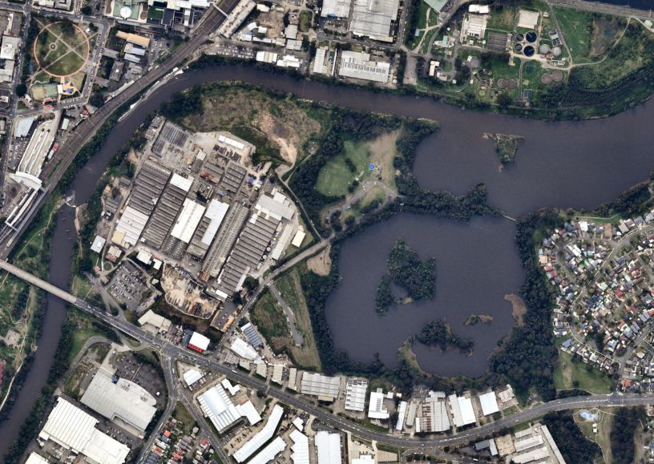
Figure 1: Aerial view of the Georges River North precinct
Source: Nearmap 03 August 2020
The planning proposal only seeks changes to those lots owned by a Joint Landowner Group (JLG) comprising Leamac Property Group and Coronation Property.
The Georges River North precinct is situated within the broader Liverpool Collaboration Area, as defined by Objective 5 of Section 3 of the Greater Sydney Regional Plan, A Metropolis of 3 Cities. The Collaboration Area includes Liverpool’s Central Business District (CBD), the health and education precinct and nearby residential and industrial land areas.
The Georges River North precinct is bordered by IN1 General Industrial zoned land to the south of Newbridge Road Street and R2 Low Density Residential to the west.
To the north of the Georges River North precinct, separated by the Georges River, is Liverpool Hospital and the Scrivener Street industrial area. The Liverpool Water Recycling Plant, owned by Sydney Water, is located to the north-east of the precinct.
To the east of the subject site is the Liverpool railway station, providing frequent services west to Leppington and east to Sydney City via Granville and north to Parramatta. To the east of the Liverpool railway station is Liverpool city centre with an abundance of employment-zoned land (B3 Commercial Core and B4 Mixed Use), schools and other educational institutions (University of Wollongong, University of Western Sydney and Liverpool TAFE), health facilities including Liverpool Hospital and retail premises including Liverpool Westfield. Figure 3 below outlines the precincts of the Collaboration Area.
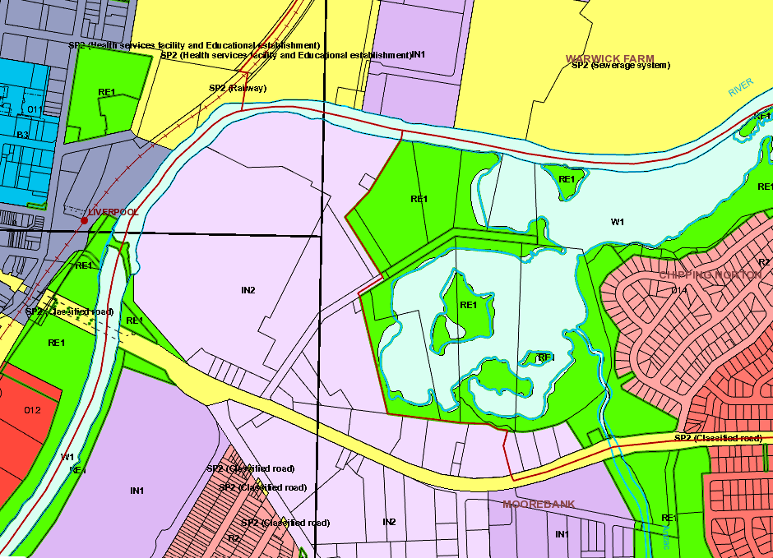
Figure 2: Current zoning of area and surrounds
Source: Liverpool City Council

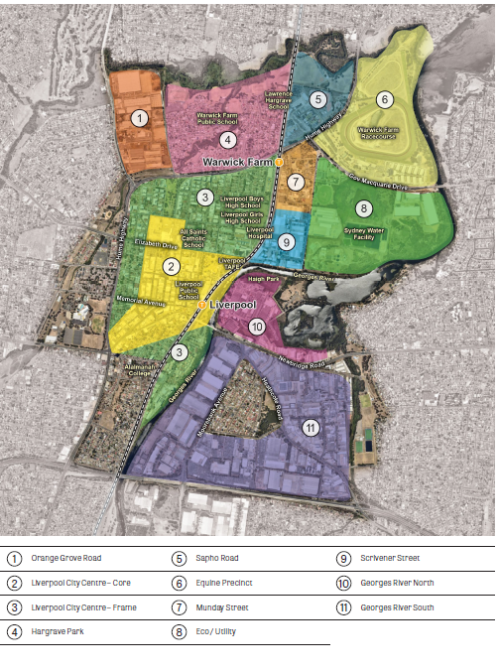
Figure 3: Liverpool Collaboration Area
NB: The subject site is depicted as “10 Georges River North”
Source: Liverpool Collaboration Area Place Strategy, Greater Sydney Commission, 2018

Site Description
The site is bounded by the Georges River and Lake Moore with frontages to Newbridge Road. The site covers an area of approximately 32 hectares and has a street frontage of approximately one kilometre to Newbridge Road, a frontage to the Georges River Foreshore of approximately 920 metres, and a 230-metre frontage to Haigh Park to the east. The site currently contains multiple industrial warehouses and business premises of various ages across multiple lots along Newbridge Road and Bridges Road. Some lots are largely vacant and contain only minor structures or recently completed roadworks.

Context

The site is located east of Liverpool CBD on the opposite side of the Georges River and north of Newbridge Road. It provides a site area of approximately 32 hectares across the joint landholdings and 38.5 hectares across the entire precinct, with most lots developed with single storey industrial warehouses and associated facilities.
The site is at the confluence of a CBD, transport interchange and health services. It is located directly across the river from Liverpool CBD, Liverpool Train Station and Bus Interchange and Liverpool Innovation Precinct.
Figure 4 below depicts land owned by Coronation Property (blue) and Leamac Property Group (yellow). Land filled purple are owned by other landowners, who are not subject to the Planning Proposal, however, are included as part of the study area to represent a holistic precinct-wide planning outcome for the area.
The Planning Proposal pertains to the area of land owned only by Coronation Property and Leamac Property Group.
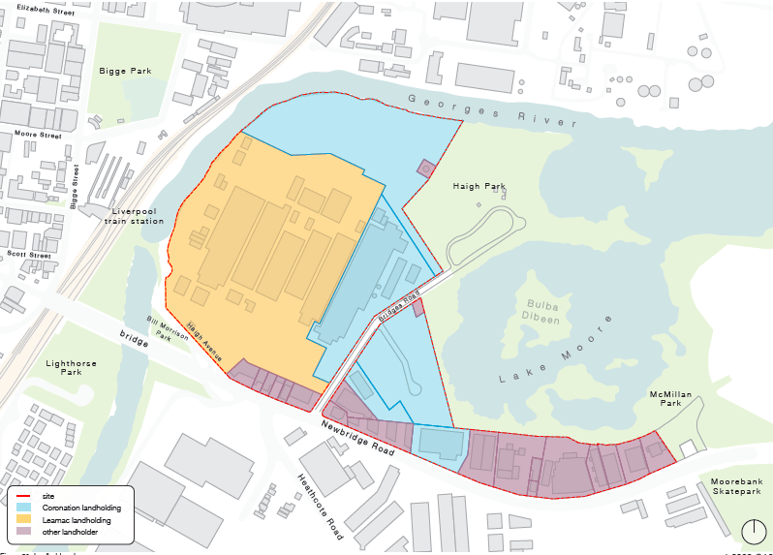
Figure 4: Subject Site (Source: SJB)
The site is currently zoned IN2 Light Industrial under LLEP 2008 however, with the release of the GSC Place Strategy and Council’s LSPS advancing a mixed use vision for the site, the current built form and use no longer reflects the desired future character of the area as Liverpool seeks to reorient itself to the Georges River. The site is located within 200m radius of Liverpool Train Station and Bus Interchange.
Under the Liverpool Collaboration Area Place Strategy, the site is identified as future ‘mixed use’ and within the Georges River North Precinct, which aims to provide a mixture of retail, residential and community uses that provide sustainable employment that is not in competition with the commercial core.
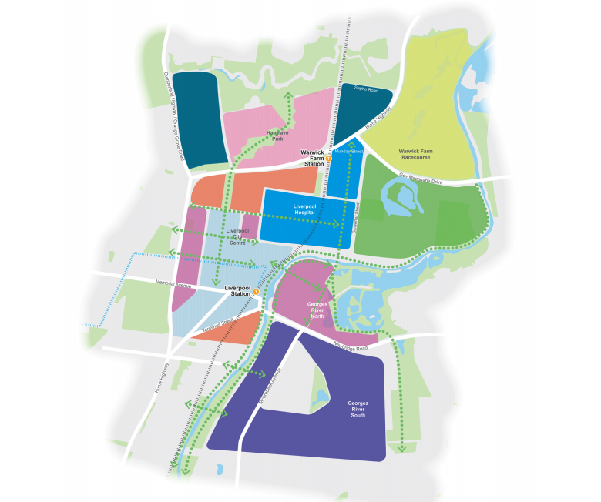
Figure 5: Liverpool Place Strategy (Source: Greater Sydney Commission)

Adjoining Sites
The site is bounded by the Georges River, Lake Moore, Haigh Park, McMillan Park and Newbridge Road, and thus there is no directly adjoining sites.
The site is uniquely positioned in the Liverpool Collaboration Area and provides excellent proximity to a range of infrastructure, jobs and services. Development to the south on the opposite side of Newbridge Road is developed with a mix of low-rise industrial developments and detached residential dwellings. Development to the west on the opposite side of the Georges River is Liverpool CBD, Train Station and Bus Interchange and Shepherd Street Precinct, which contains a mix of high-density mixed use, residential and commercial developments. Development to the north on the opposite side of the Georges River is Liverpool Hospital and a range of educational institutions including Liverpool Boys/Girls High School and TAFE NSW Liverpool.

Statutory Planning Framework

Liverpool Local Environmental Plan 2008 (LLEP 2008)

LLEP 2008 is the principal planning instrument guiding development in the LGA.
Moore Point was first acknowledged as a natural extension to the CBD via the introduction of the Standard Instrument Liverpool Local Environmental Plan 2008, which identifies land north of Newbridge Road and east of Bridge Road as part of the Liverpool city centre pursuant to Division 1 and as shown on the Key Sites map.
From a statutory perspective, the land since 2008 has been considered part of Liverpool CBD.
Table 1 provides an overview of the key local planning controls contained in LLEP 2008 in relation to the subject site.
- Liverpool Local Environmental Plan 2008
Clause/standard | Provisions
Zoning | IN2 Light Industrial.
Clause 4.1 – Minimum Lot Size | 2,000m².
Clause 4.3 – Height of Building | The site has a maximum building height of 18m and 15m.
Clause 4.4 – Floor Space Ratio | 0.75:1
Clause 5.10 – Heritage Conservation | Lot 200 DP 1009044 contains a Local Heritage Item known as – Pirelli Power Cables and Systems Building (formerly MM Cables Factory, and Cable Makers Australia Factory)
Clause 7.6 – Environmentally Significant Land | Part of the site contains Environmentally Significant Land (ESL), largely situated along the Georges River Foreshore and Lake Moore.
Clause 7.7 – Acid Sulfate Soils | The site contains Class 5 and Class 3 Acid Sulfate Soils.
Clause 7.8 – Flood Planning | The site contains land identified as High, Medium and Low Flood Risk.  The site contains land identified as Flood Planning Area (1% AEP plus 0.5 metre freeboard).
Clause 7.9 – Foreshore Building Line | Lot 200-201 DP 1009044 contain land subject to foreshore building line along the Georges River Foreshore.
Clause 7.17 – Airspace operations | The site is affected by height contours for Bankstown airport
Division 1 Liverpool City Centre | The site is located within the Liverpool City Centre Boundary as shown on the key sites map however, no lots within the site are identified as having site specific provisions.  The site is not affected by Helicopter OLS Contours.
Bush Fire Prone | Part of the site, largely east of Bridges Road, is identified as containing Bushfire Risk land in Category 1 and Buffer zones.

Part 1 – Objectives and Intended Outcome

The objectives and intended outcomes of the planning proposal are to:
- Realise Government objectives for the Georges River North Precinct, expressed both through the Place Strategy and LSPS, to provide a mixture of uses that complement the Liverpool CBD;
- Complement the objective of Liverpool Collaboration Area as a “rejuvenated river city”;
- Assist the collaboration area in achieving its 2036 job and housing targets, which include 18,800 new dwellings and 16,200 new jobs;
- Ensure infrastructure is delivered in line with development;
- Celebrate local character and heritage through the adaptive re-use of existing heritage items;
- Provide future housing and jobs within close proximity of a potential future Metro connection to Bankstown and the FAST Corridor;
- Achieve Council’s vision of the Georges River Precinct as a “true River City that has a vibrant mix of uses and activities”;
- Enhance access to the Georges River Foreshore and improve opportunities along the waterfront;
- Provide ample active and passive recreation opportunities for residents and workers in the area;
- Act as a statement of intent to set a benchmark for new development in Moorebank that prioritises a high-quality public realm;
- Provide new public domain infrastructure and uses conducive to the foreshore nature of the site;
- Deliver new pedestrian and cycleway improvements along the foreshore, and additional connections from the site to Liverpool CBD and Train Station;
- Provide a mix of uses with excellent access to existing public transport, community infrastructure, health and education services and Liverpool CBD;
- Enable new services and accommodation in close proximity to the Liverpool Health and Education Precinct and Innovation Precinct;
- Deliver a local street network and pedestrian connections to the foreshore; and
- Provide high-quality mixed-use development, which will facilitate opportunities for new employment, housing choice and public amenity.
Concept Master Plan
To support the vision, SJB have prepared a masterplan for the site and additional landholdings comprising the Georges River North Precinct. The masterplan has been in the making for several years and has been shaped through an iterative and collaborative process with Council and a number of interdisciplinary consultants.
The masterplan integrates a combination of natural and open space areas through the site in recognition of surrounding open space areas and the riverfront environment adjoining the site.
The masterplan aligns with State and local government’s view to transform land east of the Georges River and north of Newbridge Road for mixed-use purposes including residential, commercial and recreation that complement Liverpool CBD.

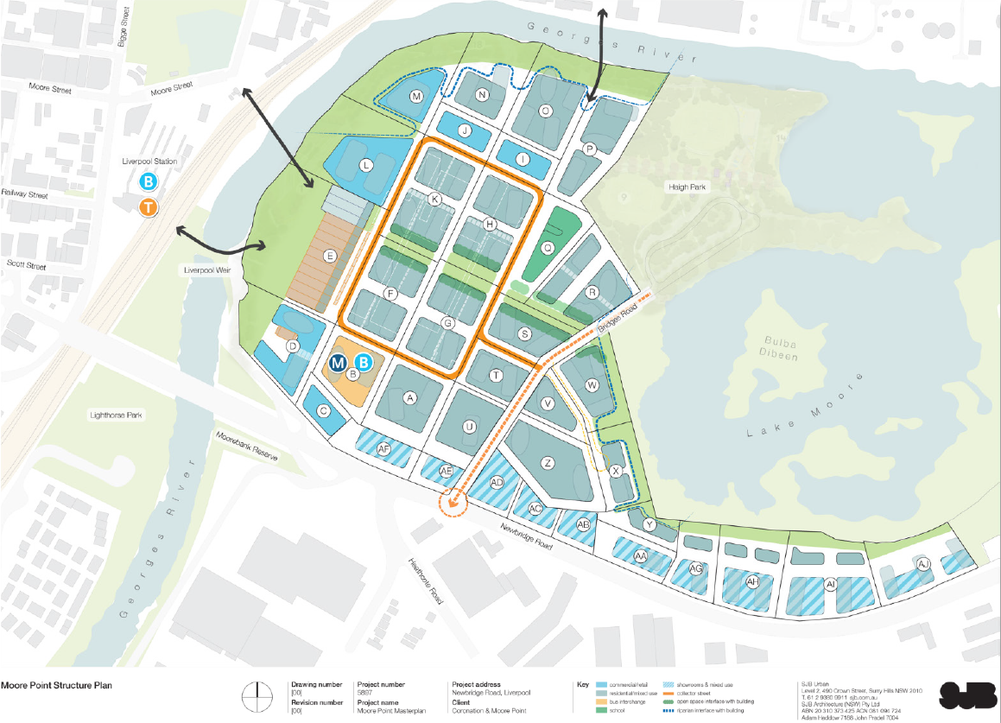
Figure 6 | Urban Design Study structure plan
Source: SJB, 2020
The masterplan is explained through a series of structure plans that detail future land uses, open space and landscaping, movement and access and activation of the site, and how it responds to strategic planning objectives for Liverpool CBD.
The above structure plan has required amendment to facilitate changes made by Council to the planning proposal request, including that 1.5 hectares (block R above) be investigated as additional open space and that there is a minimum 40m buffer of RE1 space around Lake Moore.
The changes are illustrated in Figure 7.
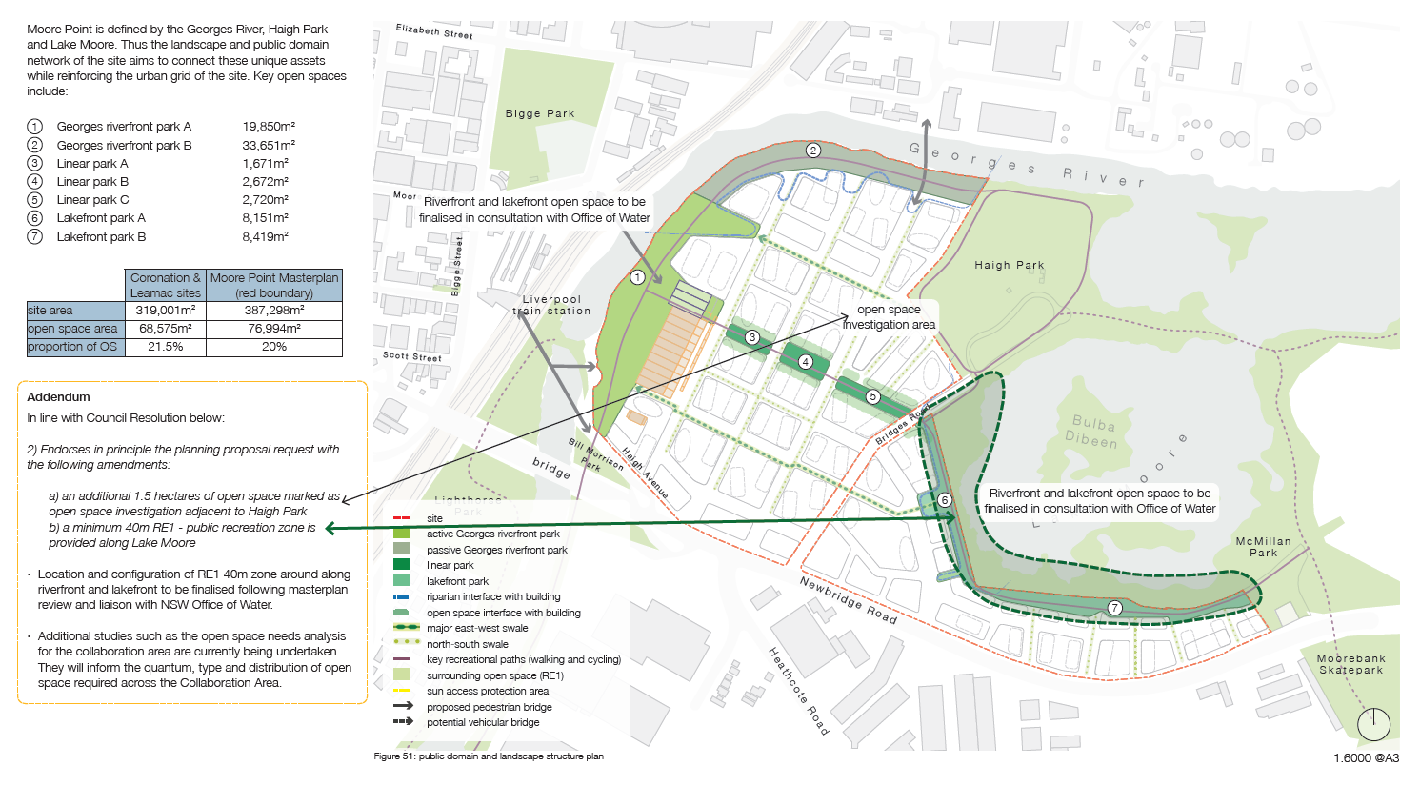
Figure 7 | Urban Design Study structure plan
Source: SJB, 2020

Part 2 – Explanation of Provisions

The planning proposal seeks to achieve the intended outcomes through the following amendments to LLEP 2008:
- Rezone the site from IN2 Light Industrial to B4 Mixed Use, B6 Enterprise Corridor and RE1 Public Recreation;
- Increase the maximum floor space ratio to part 4.2:1 and 3.5:1;
- Introduce an RL height for the site and increase the maximum height of buildings to from 18m and 15m to 136m RL and 108m RL;
- Introduce Division 1A to manage site specific provisions; and
- Introduce new subclause in Schedule 1 to permit additional uses.
- Amend Clause 7.22 (4) to read ‘Development consent must not be granted to development for the purposes of a dwelling on land shown edged heavy green on the Key Sites Map and that adjoins the Hume Highway, Newbridge Road or Elizabeth Drive unless the dwelling is at least 8 metres from any boundary of the land that adjoins either of those roads’, and amend the Key Sites Map to include the Moore Point precinct.
The relevant mapping changes are shown in Part 4 of this report.
The RL heights have been specifically determined by the Bankstown Airports Procedures for Air Navigation Services – Aircraft Operations (PANS-OPS) circling surfaces.
In order to manage site specific development outcomes on the site, it is proposed to create a new Division to LLEP 2008. It is noted part of the land is already located within Division 1 Liverpool city centre however, it is intended to amend this map to refer to Moore Point as City Centre East.
The following structure and wording are suggested:
Division 1A Liverpool city centre eastern expansion – Moore Point provisions
7.5AB Objectives for development in Moore Point
- Before granting consent for development on land in the Moore Point, the consent authority must be satisfied that the proposed development is consistent with such of the following objectives for the redevelopment of Moore Point as are relevant to that development:
- to provide building forms and land uses that are complementary to Liverpool city centre,
- to enhance the Georges River foreshore for passive and active recreational purposes,
- to enhance places of heritage significance including the Pirelli Powercables and Systems Building,
- Provide a mix of uses that exhibit a high level of design excellence,
- to provide direct, convenient and safe pedestrian links to Liverpool Train Station and Liverpool city centre,
- to ensure land uses respond appropriately to Newbridge Road including traffic and residential amenity.
7.5AC Land to which this Division Applies
- This division applies to land marked “Moore Point” on the Key Sites Map.
7.5AD Development requiring or authorising the preparation of a development control plan
- The objective of this clause is to ensure development occurs with a site-specific development control plan
- This clause applies to development on land –
  - That is shown in purple outline on the Key Sites Map that is for the purposes of a new building, which will have a gross development area in excess of 5000 sqm.
- A development control plan is not required to be prepared if the consent authority is satisfied that such a plan would be unreasonable or unnecessary in the circumstances or that the development
  - Involves only alterations and additions to an existing building, and
  - Does not significantly increase the height or gross floor area of the building, and
  - Does not have significant adverse impacts on adjoining buildings or the public domain, and
  - Does not significantly alter any aspect of the building when viewed from public places.
- Development consent must not be granted for development on land to which this clause applies unless –
  - A concept development application has been prepared or applies to the land, or
  - The development is of a minor nature and is consistent with the objectives of the zone in which the land is situated.
- The development control plan must provide for all of the following –
  - requirements as to the form and external appearance of proposed development so as to improve the quality and amenity of the public domain,
  - how proposed development addresses the following matters—
    - the suitability of the land for development,
    - the existing and proposed uses and use mix,
    - any heritage issues and streetscape constraints,
    - the location of any tower proposed, having regard to the need to achieve an acceptable relationship with other towers (existing or proposed) on the same site or on neighbouring sites in terms of separation, setbacks, amenity and urban form,
    - the bulk, massing and modulation of buildings,
    - street frontage heights,
    - environmental impacts, such as sustainable design, overshadowing and solar access, visual and acoustic privacy, noise, wind and reflectivity,
    - the achievement of the principles of ecologically sustainable development,
    - pedestrian, cycle, vehicular and service access and circulation requirements, including the permeability of any pedestrian network,
    - the impact on, and any proposed improvements to, the public domain,
    - the impact on any character area,
    - achieving appropriate interface at ground level between the building and the public domain,
    - the excellence and integration of landscape design,
    - manage the interface with industrial uses and associated amenity impacts from their ongoing operation,
    - the incorporation of high quality public art into the fabric of buildings in the public domain or in other areas to which the public has access.
7.5AE Design excellence in Moore Point
  - The objective of this clause is to deliver the highest standard of architectural and urban design.
  - Development consent must not be granted to development involving the construction of a new building or external alterations to an existing building in Moore Point unless the consent authority considers that the development exhibits design excellence.
  - In considering whether development exhibits design excellence, the consent authority must have regard to the following matters—
- whether a high standard of architectural design, materials and detailing appropriate to the building type and location will be achieved,
- whether the form and external appearance of the proposed development will improve the quality and amenity of the public domain,
- whether the proposed development detrimentally overshadows the Georges River foreshore,
- any relevant requirements of applicable development control plans,
- how the proposed development addresses the following matters—
- the suitability of the site for development,
- existing and proposed uses and use mix,
- heritage issues and streetscape constraints,
- the location of any tower proposed, having regard to the need to achieve an acceptable relationship with other towers (existing or proposed) on the same site or on neighbouring sites in terms of separation, setbacks, amenity and urban form,
- bulk, massing and modulation of buildings,
- street frontage heights,
- environmental impacts such as sustainable design, overshadowing, wind and reflectivity,
- the achievement of the principles of ecologically sustainable development,
- manage the interface with industrial uses and associated amenity impacts from their ongoing operation,
- pedestrian, cycle, vehicular and service access, circulation and requirements,
- the impact on, and any proposed improvements to, the public domain.
7.5AF Overshadowing of certain public spaces
- The objective of this clause is to protect specific public space from excessive overshadowing along the Georges River Foreshore.
- The consent authority must not grant consent to development on any land unless it is satisfied that the development will not result in any net additional overshadowing between 11am and 1pm mid-winter, on the Georges River, shown in blue hatching on the Special Provisions Area Map.
Schedule 1 Additional Permitted Uses
In recognition of the precinct’s long-term staging, it is proposed to enable the continuation of industrial related uses as the precinct develops. This will conserve existing consents over the lifecycle without creating issues regarding existing use rights.
As such, a new subclause is proposed to Schedule 1 with the following wording suggested.
Use of certain land at Moore Point in zone B4 and B6
(1) This clause applies to B4 and B6 land in Moore Point
(2) The objective of this clause is to permit industrial uses as Moore Point transitions from industrial to mixed use and residential land uses.
(3) Development for the purposes of ‘light industry’, ‘general industry’ and ‘warehouse or distribution centres’ are permitted with consent.
(4) Clauses 7.5 AD and 7.5AE do not apply to development subject to this clause.

Part 3 – Justification

This section addresses the specific questions which “must be discussed with reasons explained”, as set out in Part 3 of the NSW Department of Planning, Industry and Environment’s publication: A Guide to Preparing Planning Proposals. This section will review the proposed amendments to the Liverpool Local Environmental Plan 2008 and addresses specific questions outlined in the guide, which are separated into sections A to D.

Section A – Need for the planning proposal

- Is the planning proposal a result of an endorsed local strategic planning statement, strategic study or report?
The Planning Proposal is the direct result of a range of strategic planning studies including the Place Strategy and LSPS. These strategies provide a clear strategic line of sight aimed at the successful transformation of Liverpool CBD eastwards and the regeneration of Moorebank. Overall, it reflects strong strategic and site-specific merit to facilitate land use change.
Moore Point is an extension of Liverpool CBD realised in 2008 through the creation of LLEP 2008 and the inclusion of land north of Newbridge Road and west of Bridge Road under Division 1 – Liverpool city centre.
Place Strategy
The Place Strategy acknowledges Liverpool’s complex challenges including the provision of new local amenity along the Georges River, constrained road networks, lack of sequencing and coordination associated with planning proposals and market interests in new residential development.
The site is situated within the Georges River North Precinct, which is identified as ‘mixed use’. The mixed use area is defined as:
a mixture of commercial, retail, residential and community uses that provide sustainable employment, that is complementary to and not in competition with, the commercial core.
The Planning Proposal is directly responding to the vision of the Georges River North Precinct by providing a mix of land uses, heights and floor space amendments that will facilitate a combination of uses across the area.
Liverpool Local Strategic Planning Statement
The LSPS establishes a 20-year strategic vision for land use planning in Liverpool and the necessary actions required to align with broader regional and district planning objectives.
Key to the LSPS is the recognition of the Georges River North Precinct as future residential/mixed-use to support the CBD and Innovation Precinct as advanced through the Place Strategy.
Key actions emerging from the LSPS that directly relate to the preparation of a Planning Proposal for the site include:
- Investigate amendments to LEP to rezone River precinct north of Newbridge Road (Moore Point) as a mixed-use zone to support the Liverpool CBD and Innovation Precinct, with an extensive open space system and cross-river linkages. (short to medium term)
Short to medium term in the LSPS refers to the following periods:
• Short term – Now-2020/2021; and
• Medium term – 2021/2022-2024/2025.
Following the clear alignment between the Place Strategy and LSPS, the Planning Proposal has been prepared to realise the priorities for Liverpool.
- Is the planning proposal the best means of achieving the objectives or intended outcomes, or is there a better way?
The planning proposal is the best means of achieving the objectives and outcomes mandated in the Place Strategy and LSPS.
The site is zoned for IN2 Light Industrial purposes. Land uses within this zone are unable to achieve the mix of uses that are envisaged for the Georges River North Precinct. Therefore, a change of land use is required to facilitate a combination of residential and non-residential uses on the site.
The existing land use and development standards would not be able to deliver the public domain improvements envisaged for the Georges River North Precinct including embellishment of the foreshore, adaptive re-use of existing heritage and creation of integrated and connected pedestrian and cycle links.
While it would be possible for a rezoning to be contemplated through a comprehensive LEP review, this is considered to be a less desirable method as it would not allow for detailed site master planning or consideration of public benefits and sequencing alongside the changes to planning controls including precinct specific provisions aligned to built form considerations.
A change of land use in conjunction with amendments to key development standards and the introduction of a new Division to the LEP is necessary to transform this site into the natural extension of Liverpool CBD. This will provide land uses conducive to satisfying the objectives of the Place Strategy and LSPS as well as ensuring public benefits associated with the proposal are safeguarded.
The Planning Proposal will facilitate the following public benefits that are entirely consistent with the objectives and outcomes of the LSPS. These include:
- Riverbank rehabilitation and revegetation, including associated flooding and foreshore water quality treatments;
- Bridge connections to Liverpool CBD including 7km of shared cycle/pedestrian paths to foster healthy and socially connected communities across Liverpool;
- New public open space and upgraded parkland, enhancing the green grid and delivering bespoke and high quality open space;
- Adaptive re-use of existing heritage building and retention of heritage grid adjacent to foreshore open space, creating a destination for the community;
- Upgrades to Newbridge Road and creation of new streets, improving infrastructure an enhancing connectivity prior to the future Metro Southwest;
- Provision of cultural uses and opportunities, establishing new experiences for a diversifying Liverpool and contributing to local character;
- Contribution to the 8km ‘Georges River Walk’ from Chipping Norton to Casula Powerhouse to activate but also protect and improve the health and activation of the Georges River; and
- Capacity to provide over 23,000 jobs in excellent proximity to Liverpool CBD and the associated Health and Education Precinct, strengthening the areas productivity

Section B – Relationship to strategic planning framework.

- Will the planning proposal give effect to the objectives and actions of the applicable regional, or district plan or strategy (including any exhibited draft plans or strategies)?
Greater Sydney Region Plan
The Region Plan was published in March 2018 and sets out the vision, objectives, strategies and actions for a metropolis of three cities across Greater Sydney.
The Plan replaced the previous A Plan for Growing Sydney and outlines 10 overarching directions supported by 40 objectives, which aim to provide interconnected infrastructure, productivity, liveability and sustainability benefits to all residents.
Table 2 demonstrates the consistency of the Planning Proposal in relation to the Region Plan objectives.
Table 2: Strategic Plan Merit Test – Greater Sydney Region Plan

OBJECTIVE | REQUIREMENT | COMMENT
A CITY SUPPORTED BY INFRASTRUCTURE
Objective 1 | Infrastructure supports the three cities | The proposal seeks to align new infrastructure to support the growth of Liverpool as Sydney’s third CBD including extensive foreshore open space embellishments, creation of new roads and upgrades of existing intersections.
Objective 2 | Infrastructure aligns with forecast growth – growth infrastructure compact | The proposal aligns with population, employment and housing demand for Liverpool LGA and will be addressed through commercial and residential floor space.
Objective 3 | Infrastructure adapts to meet future needs | The proposal will provide new infrastructure along the Georges River foreshore and responds to the vision of the area articulated in the LSPS and Place Strategy. This will be achieved through further consideration of planned and future transport required to support Moore Point through the transport infrastructure working group.
Objective 4 | Infrastructure use is optimised | The proposal will locate future residents within immediate proximity to Liverpool CBD, Innovation Precinct and Liverpool Train Station.
A CITY FOR PEOPLE
Objective 5 | Benefits of growth realised by collaboration of governments, community and business | The proposal provides a complete alignment with the land uses articulated in the Place Strategy and Liverpool Collaboration Area including residential, recreational, retail and commercial uses. The proposal has established a series of working groups to drive a number of strategic objectives and principles for Moore Point.
Objective 6 | Services and infrastructure meet communities’ changing needs | The proposal will provide new open spaces, soft infrastructure such as cycle links, civic spaces, educational facilities and service that will cater for the future population growth of Liverpool.  The proposal sets aside land for a primary school and a community centre, as indicated as necessary in a Community Benefits Analysis. Further consultation will need to be held with Schools Infrastructure NSW to determine how the proposal can best satisfy the demand it will create for both primary and high schools.
Objective 7 | Communities are healthy, resilient and socially connected | The proposal will provide new pedestrian and cycleway connections to form part of a broader integrated network, promoting walkability and pedestrian movement along the Georges River foreshore, Lake Moore and Casula.  The proposal will establish a fine grain urban character in an area which is largely defined by large industrial lots as outlined in the sub-precinct character statements.
Objective 8 | Greater Sydney’s communities are culturally rich with diverse neighbourhoods | The proposal will celebrate the identity and sense of place of the River City. In particular, the proposal seeks to utilise the existing local heritage item on the site (Pirelli Power Cables and Systems Building) as a focal point and destination for Liverpool CBD. The use of this item for retail and marketplace purposes will provide opportunities to create new diverse neighbourhoods that are founded on an identity unique to the Georges River.
Objective 9 Greater Sydney celebrates the arts and supports creative industries and innovation The Proposal incorporates commercial uses at ground floor, which may assist with appropriate development of the night-time economy. | Greater Sydney celebrates the arts and supports creative industries and innovation | The proposal will provide new public spaces and street corners that will facilitate public art and opportunities for civic gathering.  The proposal will also ensure commercial/ bulky uses are retained on site to facilitate new industries and job opportunities along Newbridge Road, which is proposed to be zoned B6 Enterprise Corridor.
HOUSING THE CITY
Objective 10 | Greater housing supply | The Proposal provides greater housing supply in an optimal, city-centre location and will assist the Western City in accommodating the anticipated population increase within the next 20 years.
Objective 11 | Housing is more diverse and affordable | The proposal would increase the number of residential apartments in the area, which is the dominant dwelling structure of the locale, though detached dwellings are the dominant dwelling type across the local government area. A site-specific DCP may need to specify a higher than current proportion of one-bedroom and three-bedroom apartments to improve diversity, given a predicted increase in student and single worker populations, as well as overcrowding issues that have been identified through Council’s Local Housing Study.  A Community Benefits Analysis provided indicates that the proposal could “deliver at least 5% affordable housing for key workers”, which is in line with the Regional Plan’s inclusionary zoning target of 5-10% “in defined precincts prior to rezoning”. Mechanisms for ensuring affordable housing is delivered will need to be explored.
A CITY OF GREAT PLACES
Objective 12 | Great places that bring people together | The proposal seeks to unify Liverpool CBD with Moorebank. Under the current planning provisions, the site fails to respond and complement the changing aspirations and vision of Liverpool CBD.  The proposal will rebalance Liverpool CBD and focus of a vibrant mix of uses oriented around the Georges River foreshore including passive and active recreational opportunities and bridge connections.
Objective 13 | Environmental heritage is identified, conserved and enhanced | The proposal will adaptively reuse a local heritage item on the site (Pirelli Power Cables and Systems Building) for a future retail and marketplace.  This will ensure that the unique environmental assets of the site are utilised and celebrated.
A WELL-CONNECTED CITY
Objective 14 | A Metropolis of Three Cities – integrated land use and transport creates walkable and 30-minute cities | The site is located within excellent proximity of Liverpool CBD, which connects residents and employers across Sydney and to the future Badgery’s Creek Aerotropolis.  The proposal will provide new cycle and pedestrian links coordinated across the Moorebank area to improve connections to Liverpool CBD.  The proposal provides capacity for a future Southwest metro extension into Liverpool CBD, which would further integrate land use around transport.
JOBS AND SKILLS FOR THE CITY
Objective 20 | Western Sydney Airport and Badgerys Creek Aerotropolis are economic catalysts for Western Parkland City | The proposal will ensure residents are living within a closer proximity to the potential economic benefits of Badgery’s Creek and the western city, which will be accessible via the FAST Corridor.
Objective 21 | Internationally competitive health, education, research and innovation precincts | The proposal will contribute to the regeneration of Moorebank, facilitating new residents into the area who will benefit from close proximity to Liverpool’s existing key education and health assets and transport infrastructure.  The proposal will facilitate high-quality residential and services in close proximity to the major Liverpool institutions including Western Sydney University and Liverpool Hospital, as well as providing capacity for educational and cultural institutions on the site.
Objective 22 | Investment and business activity in centres | The proposal will facilitate increased business activity in Moorebank and Liverpool CBD by providing critical mass of new residents. This in turn will facilitate the demand for additional services and business in the CBD and the site itself.  Importantly, the uses and floorspace proposed would act as complementary, and not in competition with the CBD. The proposal has capacity to deliver 23,000 new jobs in the long-term up to 2051.
Objective 23 | Industrial and urban services land is planned, retained and managed | The proposal seeks to rezone land from industrial to mixed use and recreational purposes.  The District Plan states that where appropriate, conversion of industrial lands into other uses may be appropriate. Moore Point is identified in the District Plan as ‘Review and Manage’.  As identified in the Place Strategy, the site is located in the Georges River North Precinct, which is envisaged to accommodate a mix of land uses. Furthermore, the adopted LSPS advances a mixed-use vision for the Precinct via a rezoning in the short to medium term.  There has been a clear mandate from a suite of strategic planning documents to reconsider land uses east of the Georges River and north of Newbridge Road for mixed use purposes.  Given the strategic line of sight and consistency amongst strategic planning to see a mix of uses on the site, the site provides a circumstance where conversion would be appropriate to satisfy the overall strategic vision for Liverpool’s diversifying and expanding CBD.  An Economic Impact Assessment has also been prepared by Hill, which considers the potential loss of industrial lands.
Objective 24 | Economic sectors are targeted for success | The proposal will increase employment opportunities in the precinct by proposing non-residential floor space that can be allocated to a mix of entertainment, retail, commercial and business uses. The proposal is capable of delivering up to 23,000 new jobs by 2051.
A CITY IN ITS LANDSCAPE
Objective 25 | The coasts and waterways are protected and healthier | The proposal will contribute to the remediation and revitalisation of the Georges River foreshore by improving foreshore vegetation and bank stabilisation.
Objective 27 | Biodiversity is protected, urban bushland and remnant vegetation is enhanced | The proposal will revitalise parts of the Georges River foreshore, facilitating new landscaping, vegetation and tree planting across the site.  The site in its current state and capacity under existing planning controls fails to incentivise or facilitate additional tree canopy or landscaping.
Objective 28 | Scenic and cultural landscapes are protected | The proposal will ensure future residents and visitors will benefit from new views and vistas towards the Georges River foreshore.
Objective 29 | Environmental, social and economic values in rural areas are protected and enhanced | The proposal will strengthen the environmental, social and economic values of the area by celebrating cultural heritage items on the site and surrounding environmental assets including Haigh Park, Lake Moore and the Georges River foreshore.
Objective 30 | Urban tree canopy cover is increased | The site currently has no landscaping, accommodating a single storey building and hardstand for the entirety of the site. The Concept Plan submitted with the Planning Proposal demonstrates a significantly greater provision of landscaping and common and private open space opportunities.
Objective 31 | Public open space is accessible, protected and enhanced | The proposal seeks to create and embellish open space across the site and improving Sydney’s green grid connections to Liverpool CBD and the Georges River
Objective 32 | The Green Grid links parks, open spaces, bushland and walking and cycling paths | The proposal will deliver a green and blue grid, integrating the site with a series of bespoke landscape and open space areas supporting by pedestrian and cycling infrastructure. The proposal facilitates public access to the riverfront and previously underutilised open space.
AN EFFICIENT CITY
Objective 33 | A low-carbon city contributes to net-zero emissions by 2050 and mitigates climate change | The proposal will contribute to a more sustainable and resilient city through remediation of the Georges River and the utilisation of ESD principles in future development. A Placemaking Working Group has been established between Council and the proponents to explore placemaking and sustainability opportunities post-Gateway.
Objective 34 | Energy and water flows are captured, used and re-used | The proposal will provide uses that will enable WSUD and ensure water is appropriately drained across the site.  A Placemaking Working Group will drive sustainability governance for the site (actions 30-35). The Group will have representation from Council, the project team and relevant State agencies.  It is the intention for development to incorporate water sensitive urban design through a site-specific DCP. Ongoing consultation with Sydney Water to investigate recycled water provision on-site has also been encouraged.
Objective 35 | More waste is re-used and recycled to support the development of a circular economy | The proposal will facilitate a mix of land uses that can utilise recycled water for landscaping and WSUD.
A RESILIENT CITY
Objective 36 | People and places adapt to climate change and future shocks and stresses | The proposal will deliver a resilient waterfront that is able to respond to the varying shocks and stresses of the Georges River. The proposal aligns with the foreshore building line in accordance with the LEP.
Objective 37 | Exposure to natural and urban hazards is reduced | The site currently sits within the flood planning area, with much of the site subject to 1-in-100-year flood events. The land owners have advised that there is likely to be an engineering solution to make the development site suitable for residential development with off-site flood mitigation works, however further investigations needs to be conducted post-Gateway to ensure this is a workable and acceptable solution to Council.
Objective 38 | Heatwaves and extreme heat are managed | The proposal will deliver additional landscaping and tree plantings on the site and along the riparian waterfront, improving the overall urban cooling of the site.

Western City District Plan
The subject site is located within the Liverpool City Centre, which forms a part of the Western City District. The Western City District Plan (the District Plan) sets out planning priorities and actions for improving the quality of life for residents as the district grows and changes. The District Plan provides a 20-year strategy to manage growth in the context of economic, social and environmental matters. It is a guide for implementing the Greater Sydney Region Plan, at a district level.
The District Plan establishes 22 Planning Priorities, which shape the vision for the future of the Western City District. The Planning Proposal is consistent with the relevant planning priorities and actions of the District Plan. The following table provides a summary of the Planning Proposal’s consistency with the District Plan, including actions for Collaboration Areas and Liverpool.
Table 3: Strategic Plan Merit Test – Western City District Plan
Planning Priority | Comment
W3 – Providing services and social infrastructure to meet people’s changing needs | The proposal sets aside land for a primary school and a community centre, as indicated as necessary in a Community Benefits Analysis. Further consultation will need to be held with Schools Infrastructure NSW to determine how the proposal can best satisfy the demand it will create for both primary and high schools.
W4 – Fostering healthy, creative, culturally rich and socially connected communities | The Urban Design Study envisages a walkable precinct with most residential development within a 200m radius of open space, and a high level of tree canopy to reduce the urban heat island effect and encourage walkability. The sites location is near to Liverpool Station, which is predicted to reduce car dependence, and it is proposed that heritage assets are repurposed into a community market.
W5 – Providing housing supply, choice and affordability, with access to jobs, services and public transport | The proposal increases housing supply and access to jobs, services and public transport. The proposal does not indicate measures to improve housing affordability, such as a percentage of housing to be provided as affordable rental housing. Further discussion with DPIE/GSC will be required.
W6 – Creating and renewing great places and local centres, and respecting the District’s heritage | The proposal will reconnect the Liverpool city centre area to the Georges River and provide a continuous public open space network. It is envisaged that through a site-specific DCP a high amenity and connected precinct will result. A historical heritage assessment has indicated that three buildings – two 1940s sawtooth factory buildings and a front façade of an administration building – have high heritage value. The planning proposal request indicates that part of the two sawtooth factory buildings will be retained and adaptively reused for the purpose of a retail marketplace. The Administration building will also be retained and adapted for re-use.
W9 – Growing and strengthening the metropolitan cluster | The proposal will provide further housing and jobs to support the development of Liverpool as a metropolitan cluster, however the scale of development and amount of commercial floorspace indicated could compete with the existing commercial core if not appropriately managed and development staged.
W11 – Growing investment, business opportunities and jobs in strategic centres | An increase in residential and commercial development will support investment, business opportunities and jobs in the Liverpool city centre. An improvement in amenity and additional open space around the Georges River will also increase the attractiveness of the area as an investment destination.
W12 – Protecting and improving the health and enjoyment of the District’s waterways | The proposal seeks to rezone industrial land around the Georges River to RE1, which will better protect the waterway while enhancing liveability by improving access and recreation opportunities. Some parts of planning proposal request impinge on Coastal Wetland Areas and may need to be revised to meet this Objective and Ministerial Directions.
W15 – Increasing urban tree canopy cover and delivering Green Grid connections | The proposal provides green corridor connections between Liverpool Station and Haigh Park. The Urban Design Study also states an intention to significantly increase urban tree canopy on-site to 25%.
W18 – Delivering high quality open space | The proposal will provide additional open space in the city centre and provide better access to natural assets, such as Lake Moore. An Interim Letter of Offer also states that park embellishments could be provided as part of a public benefits package through a voluntary planning agreement. Council is undertaking an open space needs assessment to determine whether additional open space is required on site.
W19 – Reducing carbon emissions and managing energy, water and waste efficiently | A Placemaking Working Group has been established between Council and the proponents to explore placemaking and sustainability opportunities post-Gateway, which could include ways the proposal can address climate change. It is the planning proposal’s intention for development to incorporate water sensitive urban design through a site-specific DCP. Ongoing consultation with Sydney Water to investigate recycled water provision on-site has also been encouraged.
W20 – Adapting to the impacts of urban and natural hazards and climate change | The site currently sits within the flood planning area, with much of the site exposed to 1-in-100-year flood events. There is likely to be a solution to make the development site suitable for residential development with off-site flood mitigation works, however further investigation needs to be conducted post-Gateway to ensure this is a workable and acceptable solution to Council.
Actions for the Collaboration Area
1. Increase housing diversity and provide affordable housing | The proposal will provide residential apartments on site. Take-up analysis indicates demand for approximately 6,900 dwellings to 2036.  The additional housing proposed will provide housing choice and diversity.
2. Improve and coordinate transport and other infrastructure to support job growth | The proposal integrates active modes of transport with public transport infrastructure including new cycle links and pedestrian connectivity to Liverpool Train Station.  The future South West Metro extension will further reinforce the suitability of new development in Moorebank. The project team has established a TIWG to ensure place-based transport infrastructure can be planned and delivered in line with the site’s rezoning.
3. Develop smart jobs around the health and education precinct, particularly in the areas of advanced manufacturing and logistics, automation and translational research | The proposal will ensure smart jobs can be pursued through the B6 Enterprise Corridor zone located along Newbridge Road to ensure smart jobs align with the function of Newbridge Road.  The B6 Enterprise Corridor provides for land uses that are conducive to the creation of smart jobs on the site.
4. Improve the night-time economy, mixed use and transport connections | The proposal will facilitate the creation of a nigh-time economy through the proposed B4 mixed use zoning, which can facilitate a variety of active uses.
5. Improve urban liveability and Liverpool’s sense of place | The site’s current zoning and planning controls do not improve urban liveability or allow residents to celebrate the cities sense of place.  The proposal will transform Liverpool CBD into Sydney’s third CBD with significant investment in open space and public domain, high-quality mixed-use buildings and celebration of local heritage and orientation towards natural assets.
6. Improve environmental outcomes around the Georges River | The current industrial use on the site is considered to have a higher impact in regard to the health and remediation of the surrounding river and waterways. The current use of the site provides no incentive to respond to its foreshore setting via built form and design of buildings.  The proposal will result in uses that have lower impact on the Georges River in tandem with bank rehabilitation for passive recreational uses.
7. Develop Greater Sydney Green Grid projects | The proposal will deliver a suite of open spaces and form part of a more integrated open space network for the Moorebank area.
8. Capitalise on Western Sydney Airport and the Western Sydney City Deal | The proposal capitalises on the opportunities presented by the Western Sydney City Deal and Western City Airport by providing a catalyst for urban regeneration east of Liverpool CBD and strengthening its prominence as Sydney’s third CBD.
9. Revitalise Liverpool CBD | The proposal will rebalance Liverpool CBD towards the Georges River, which has been a clear objective of Council and Government for land east of the Georges River.  The proposal will complement the revitalisation of Liverpool CBD by increasing residential and non-residential uses in tandem with new open space and infrastructure improvements.
10. Examine flooding issues and water management | The proposal has considered flooding on the site and has demonstrated that development of the land may proceed in a manner that should not result in increased flooding either on or off the site.
11. Consider the opportunities presented by the Liverpool Water Recycling Facility | The proposal does not interfere with the Liverpool Water Recycling Facility. Further discussion will occur regarding the potential for using recycled water.
Actions for Liverpool
a) Protect and develop the commercial core | The proposal will strengthen the critical mass available to Liverpool’s commercial core, by providing for new residential communities that require access to goods and services in Liverpool CBD. It will aim to provide uses that are complementary to the CBD.
b) Improve and coordinate transport and other infrastructure to support jobs growth | The proposal will provide new active transport options across the site, acting as a catalyst for wider regional active transport links to the CBD.  The proposal will provide new bridge crossings over the Georges River to Liverpool CBD and Train Station, ensuring new residents have access to services and employment.
c) Develop smart jobs around the health and education precinct | The proposal will provide for new higher order commercial uses on the site through the B4 Mixed Use and B6 Enterprise Corridor Zone.
d) Build on the centre’s administrative and civic role | The proposal does not undermine Liverpool’s administrative and civic role.
e) Improve public domain including tree-lined, comfortable open spaces and outdoor dining | The site has traditionally operated for uses that does not require consideration of the public domain, street trees, open spaces and outdoor dining. The proposal will facilitate transformation of the site for mixed use purposes, ensuring open space, tree plantings and active frontages are introduced to promote the public domain.
f) Improve connectivity and links to the Georges River and prioritise pedestrian, cycle and public transport facilities | The proposal will provide cycle links along the Georges River foreshore and pedestrian links to Liverpool CBD and Train Station.
g) Encourage vibrant mix of uses, new lifestyle and entertainment uses to activate streets and grow the night-time economy | The current planning controls and controls only allow for more intensive employment related uses and do not encourage a vibrant mix of lifestyle and entertainment uses.  The proposal will facilitate a mixed-use precinct consistent with the vision of the Georges River North Precinct.
h) Capitalise on the Western Sydney Airport and Western Sydney City Deal initiatives | The proposal capitalises on the Western Sydney Airport and Sydney City Deal by reinforcing the role of Liverpool as a major centre in Western Sydney.  The FAST Corridor will also ensure future residents can access the Western Sydney Aerotropolis, increasing job accessibility.

Does the proposal have strategic merit? Will it:
- Give effect to the relevant regional plan outside of the Greater Sydney Region, the relevant district plan within the Greater Sydney Region, or corridor/precinct plans applying to the site, including any draft regional, district or corridor/precinct plans released for public comment; or
- Give effect to a relevant local strategic planning statement or strategy that has been endorsed by the Department or required as part of a regional or district plan or local strategic planning statement; or
- Responding to a change in circumstances, such as the investment in new infrastructure or changing demographic trends that have not been recognised by existing strategic plans?
In considering strategic merit, the alignment of the proposal with the Regional Plan and District Plan supports the proposal. These land uses are further reinforced in Liverpool City Council’s Local Strategic Planning Statement (LSPS), which identifies the site for investigation as residential/mixed use to support the CBD and Innovation Precinct in tandem with linking open space and green corridors.
Key to the LSPS is the recognition of Moore Point as future residential/mixed-use to support the CBD and Innovation Precinct. Key themes emerging from the LSPS that relate to future strategic planning for the site include:
The LSPS provides the following short-term action (now—5 years) specific to the Moore Point:
“Action 11.2 – Investigate amendments to LEP to rezone River precinct north of Newbridge Road (Moore Point) as a mixed-use zone to support the Liverpool CBD and Innovation Precinct, with an extensive open space system and cross-river linkages (short to medium term)”.
In addition to meeting at least one of the strategic merit criteria, a planning proposal is required to demonstrate site-specific merit against the following criteria below.
Does the proposal have site specific merit, having regard to the following:
- The natural environment (including known significant environmental values, resources or hazards);
A summary of technical study findings in relation to known significant environmental values, resources or hazards is summarised below.
Biodiversity
With respect to biodiversity, Eco Logical Australia note the study area has been subject to considerable vegetation disturbance and does not contain any remnant native vegetation.
One threatened ecological community River-flat Eucalypt Forest on Coastal Floodplains of the NSW North Coast, Sydney Basin and South Eastern Bioregions listed as an endangered ecological community (EEC) and has been mapped as occurring within the study area. The vegetation has been established through revegetation works. It contains high weed blooms and is in poor condition. Therefore, it did not satisfy listing criteria under the Environmental Protection Biodiversity Conservation Act (EPBC Act).
One matter of National Environmental Significance was identified as having potential to be adversely affected by the proposed works is the Pteropus poliocephalus (Grey-headed Flyingfox), which is listed as a vulnerable species under the EPBC Act. It is considered that this species is likely to use some of the study area for seasonal foraging. An assessment on the
Commonwealth Significant Impact Criteria is required for species listed under the EPBC Act and submitted with a Biodiversity Development Assessment Report (BDAR).
Contamination
With respect to known contamination, EI Australia conclude a combination of the following remedial options may be implemented to remediate the site for its intended purpose:
Excavation and On-site Encapsulation – Involving excavation of impacted soils from bulk excavations that are intended for the construction of basement car parking facilities followed by onsite reuse to the extent possible. On-site containment of contaminated soils by way of capping and/or encapsulation within low permeability cells or other appropriately designed barrier system, where subsurface or above-ground storage areas are available. Contaminated materials that are retained on-site will need to be managed under a site-specific LTEMP, which will include periodic groundwater monitoring to confirm that off-site containment migration is not occurring. Should off-site mitigation be detected, then contingent groundwater measures will need to be implemented;
Excavation and Off-site Disposal – Involving excavation of impacted soils from bulk excavation followed by off-site disposal of surplus impacted soils to licensed waste landfill;
In-site Soil Vapour Extraction – Coarse grained soils impacted with VOCs (including chlorinated VOCs, light fraction petroleum hydrocarbons and BTEX), may be treated in-situ by extracting soil vapour under vacuum, via horizontal vent pipes installed in trenches throughout the impacted area. The contamination is drawn out of the soil as vapour and liquid, which are collected for appropriate on-site treatment and/or offsite recycling; and
Ex-situ Bioremediation with Soil Vapour Extraction – Coarse grained soils impacted with VOCs (including chlorinated VOCs, light fraction petroleum hydrocarbons and BTEX), may be treated ex-situ by extracting soil vapour under vacuum, via horizontal vent pipes installed in bio-piles created from the excavation of impacted soils. The contamination is drawn out of the soil bio-piles as vapour and liquid, which are collected for appropriate on-site treatment and/or off-site recycling.
Overall, once the data gap closure investigations are available, the remedial strategy may be refined. A detailed, site-specific remedial action plan (RAP) is required for each site, before the commencement of site remediation. The site-specific RAP must include an Unexpected Finds Protocol to provide guidance on addressing unexpected contamination that may be identified during the course of site redevelopment.
Council has requested refinements to the contamination study be provided post-Gateway.
Riparian
With regards to the riparian corridor, Northrop consider for most of the site, the riparian corridor will contain three structured zones, i.e. Riverbank, Inner VRZ and Outer VRZ, which is consistent with the National Resources Access Regulator (NRAR) Riparian Guideline. However, the creation of the Georges River foreshore park as envisioned does not conform to the Guideline.
Therefore, a merit-based approach to assess this strategy for the entire site is proposed, which relies on offsetting for an overall improved environmental outcome. Northrop conclude that the outcomes presented above provide a significant environmental improvement for the site and Lake Moore. The approach has a sound rationale, which justifies a merit-based assessment on this basis.
Flooding
With regards to flooding, J. Wyndham Prince note the current floodplain storage during the 1% AEP event has considered the proposed development landform and regional floodplain reclamation strategy. The proposed implementation of the two flood storages and on the banks on the Georges River adjacent to the western motorway will result in an increase in the available floodplain storage by 31,930m3.
J. Wyndham Prince conclude the detailed flood assessment for the strategy has demonstrated that, with the site, peak flood levels in surrounding properties and within the Georges River will not increase as compared to existing conditions in the catchment in the 1% AEP events. Importantly, provision of the proposed flood levels to the south of Newbridge Road will also reduce the extent of flooding within the Moorebank area, which is therefore considered to be an improvement upon existing conditions.
Council has requested that refinements to the flooding and flood evacuation studies be provided post-Gateway.
Aboriginal Heritage
With respect to Aboriginal heritage, EI Australia assert that development is not proposed in the area noted as having moderate archaeological potential, which will be used for a planned riparian corridor. The remainder of the study area possesses low archaeological potential and no further assessment is therefore required.
Air Quality
With respect to air quality, Todoroski Air Sciences conclude there is no reasonable indication of any likely air quality impacts that may prevent development at this location. It is anticipated a detailed study would be required as part of the Development Application process.
Based on the technical study findings, it is considered that the site is not constrained by any known environmental values, resources or hazards and that rezoning of the site for residential/mixed-use purposes can proceed.
Further consultation will need to be conducted with Sydney Water regarding the odour buffer from its Liverpool wastewater treatment plant.
- The existing uses, approved uses, and likely future uses of land in the vicinity of the proposal; and
Moore Point has traditionally been dominated by monofunctional industrial uses. As such, the prescribed land use and development standards for the site fail to respond to the growing role of Liverpool CBD, the Innovation Precinct and broader strategic vision for the Liverpool Collaboration Area. Overall, the existing uses on the land do not represent the desired future uses.
Under the Place Strategy, it is envisaged that Liverpool will become a rejuvenated river city, providing diverse growing residential and employment opportunities in tandem with an integrated network of open spaces along the Georges River.
The Planning Proposal will facilitate land uses conducive to the vision for Liverpool and will become a thriving residential and mixed-use precinct that complements Liverpool CBD. This will be achieved through the B4 mixed-use and B6 Enterprise Corridor zoning to facilitate a mix of residential towers and a genuine mix of commercial offerings including tourism and visitor accommodation, serviced apartments, seniors living, commercial, business and retail uses.
Key to the Planning Proposal is the proposed Georges River foreshore remediation, which will establish a contiguous foreshore link from Haigh Park to Lighthorse Park. This will be supported by 7km of cycle/pedestrian paths as well as new bridge crossings to Liverpool CBD and transport interchange.
This ensures the Planning Proposal complements future land uses within the vicinity of the proposal, such as the growing innovation/research/health and advanced manufacturing precinct north of the site and broadly aligns with a holistic planning outcome for the area.

- The services and infrastructure that are or will be available to meet the demands arising from the proposal and any proposed financial arrangements for infrastructure provision?
The proposed future infrastructure provision associated with future staging and development of Moore Point. This is considered with respect to utilities, transport infrastructure and social infrastructure.
Utilities
With respect to services and utilities, ADW Johnson confirms all authorities have advised that they can service the proposed overall development outcome. In some cases, upgrades to the existing network will be required. This is summarised below.
Sydney Water
- Upgrade of potable water supply likely;
- Major upgrade of existing pumping station to be completed to service development.
The upgrade works will be completed by Sydney Water and take an estimated 3 years from concept to completion.
Endeavour
- Eight new 11kV feeders from Moorebank Zone Substation;
- Six new circuit breaker terminations at Moorebank Zone Substation; and
- Two new switching stations at Moorebank Zone Substation.
NBN Co
- Fibre connecting the site to the existing Liverpool Fibre Access Node (FAN) to be constructed by NBN.
Jemena
- Installation of below-ground regulator station.
Social Infrastructure
Cred Consulting have reviewed the Planning Proposal and supporting masterplan to identify the following social infrastructure requirements to support Moore Point. These include:
- New multipurpose community hub – approx. 2000m2;
- New local facility with indoor and outdoor space – approx. 400m2;
- Repurposing Moorebank Library and Community Centre to a district level multipurpose library facility – approx. 598m2 to 2036 and 1,365m2 to 2051;
- Deliver 1 new primary school, including Out of School Hours Care built facility;
- Provision of quality early education and childcare centres (under 90 places);
- Deliver a total of at least 7.7. hectares of new quality open space. Should be delivered as 6.2 hectare of local parks of a minimum size of 0.3 hectares to 0.5 hectares. Parks should be within 200m of resident homes;
- Deliver up to 3 new (or embellished) district sports-fields including:
- 1 new sports-field space within the precinct up to 2051;
- Embellishments to Haigh Park to deliver additional sports-fields for informal team sports by 2036;
- Protection and enhancement of Satyam Ghat.
- Up to 4.5/5 playgrounds for young children (0 to 4) by 2051 and up to 4 playgrounds for older children (5 to 11) by 2051 located throughout the precinct next to new open spaces;
- Up to 1 regional/district level outdoor youth recreation precinct. This could be provided through embellishment to existing Kelso Skate Park or through a new youth focused outdoor recreation space;
- 1 indoor recreation centre providing up to 4 indoor courts that support a range of culturally appropriate sports such as futsal, indoor volleyball, badminton and table tennis;
- Provision of a water launch point for passive boating and viewing decks for passive recreation and fishing at Lake Moore;
- Communal pools or a contribution to improving facilities at Whitlam Centre;
- Provision of communal facilities within residential towers; and
- 5% of affordable housing for key workers.
The Planning Proposal is capable of delivering upon many, if not all, of the community infrastructure items recommended by Cred and are detailed within the masterplan.
Infrastructure funding for specific items will be dealt with separately through a site-specific Section 7.11 Contributions Plan to be prepared in collaboration with Council following Gateway Determination. A letter of offer has been received for items unable to be funded through a Section 7.11 Contributions Plan.
Specific to the Planning Proposal, items captured through the Contributions Plan that align with Cred’s recommendations could include:
- Multi-purpose community centres;
- Rehabilitation and embellishment of the Georges River foreshore and Lake Moore;
- Pedestrian bridge from Moore Point to Liverpool CBD;
- Dedicated pedestrian and cycle paths;
- Creation of new open space along Georges River foreshore;
- Heritage conservation and adaptive re-use of existing heritage building as new marketplace;
- Embellishment and upgrade of existing local open spaces in the surrounding locality;
- Intersection upgrade works at Newbridge Road; and
- Creation of new local streets and collector roads.
Transport Infrastructure
Due to the size, scale and influence of the Planning Proposal, a traffic assessment that looks at transport capacity in isolation would not accurately reflect the overall demand for transport infrastructure in Liverpool.
As a result, the project team in consultation with Council and Transport for NSW (TfNSW) have established a Transport Infrastructure Working Group (TIWG). The TWIG will involve TfNSW and Council to ensure the Planning Proposal aligns with the overarching Place Strategy for Liverpool Collaboration Area and the successful integration of Moore Point into the current and future planned transport network.
Transport infrastructure will be carefully considered through the rezoning process and addressed through a two-stage approach involving:
- Due Diligence and Strategic Assessment; and
- Detailed Transport and Traffic Assessment.
Importantly, Stage 1 will deliver a Preferred Land Use and Transport Infrastructure Scenario for Moore Point and the wider Collaboration Area, which will include:
- A Land Use and Transport Strategy for the Collaboration Area;
- A high level cost estimate of key infrastructure requirements and transport access strategy for interim and ultimate development scenarios; and
- An agreed funding mechanism.
It is expected that these deliverables will establish the required transport infrastructure needed to support the Planning Proposal and will be progressed through the Gateway process in collaboration with the TIWG and key agencies.
The scope of each study is documented within the Strategic Transport Assessment prepared by Aurecon.
For the reasons outlined above, the planning proposal is considered to satisfy the site-specific merit test.
- Will the planning proposal give effect to a council’s endorsed local strategic planning statement, or another endorsed local strategy or strategic plan?
Connected Liverpool 2040 (LSPS)
Connected Liverpool 2040 is Liverpool Council’s local strategic planning statement (LSPS).
The subject planning proposal gives effect to the LSPS, which states:
- Local Planning Priority 7– Housing choice for different needs, with density focused in the City Centre and centres well serviced by public transport
  - Council will – Ensure housing typologies are diverse and appropriately located to cater for the entire community
The planning proposal will facilitate the development of additional housing types in the Liverpool City Centre.
Liverpool Community Strategic Plan – Our Home, Liverpool 2027
The proposal gives effect to the Liverpool’s Community Strategic Plan (CSP) – Our Home, Liverpool 2027, which states:
- Direction 2: Strengthening and Protecting our Environment
  - Council will: Exercise planning controls to create high-quality, inclusive, urban environments.
The proposed amendment will facilitate the efficient development of the subject site in a manner that creates a high-quality built form outcome, with negligible environmental implications.
- Direction 3: Generating Opportunity
  - Council will: Meet the challenges of Liverpool’s growing population.
The ability to develop residential housing will work to meet the CSP Direction. Efficient development of the site will be facilitated to meet the population growth occurring within Liverpool and the wider Metropolitan Sydney area.
- Is the planning proposal consistent with applicable State Environmental Planning Policies?
Table 4: Consistency with State Environmental Planning Policies
Table 4: State Environmental Planning Policies
SEPP | Consistency | Comments
SEPP No. 19 – Bushland in Urban Areas | Not Applicable.
SEPP No 21 – Caravan Parks | Not Applicable.
SEPP No. 33 – Hazardous and Offensive Development | Consistent. | The proposal will adopt the standard instrument definitions of hazardous and offensive development, which are not permitted on the site.
SEPP No. 36 – Manufactured Home Estates | Not Applicable.
SEPP No. 47 – Moore Park Showground | Not Applicable.
SEPP no. 50 – Canal Estate Development | Not Applicable.
SEPP No. 55 – Remediation of Land | Consistent. | The site will be appropriately remediated to ensure it is suitable for residential development.  A Preliminary Site Investigation (PSI) report has been prepared to support the Planning Proposal and concludes the site can be remediated for its intended purpose. Refer to Appendix 10.
SEPP No. 64 – Advertising and Signage | Consistent. | The proposal does not contradict or hinder the application of the SEPP.
SEPP No. 65 – Design Quality of Residential Apartment Development | Consistent. | The building envelope established by the proposal is capable of accommodating residential and mixed-use development that is consistent with SEPP 65 principles and with the Apartment Design Guide.  An overview of the proposal’s ability to comply with key ADG criteria is provided with the urban design study.
SEPP No. 70 – Affordable Housing (Revised Schemes) | Not Applicable.
SEPP (Aboriginal Land) 2019 | Not Applicable.
SEPP (Affordable Rental Housing) 2009 | Consistent. | The proposal does not contradict or hinder the application of the SEPP.
SEPP (Building Sustainability Index: BASIX) 2004 | Consistent. | The proposal does not contradict or hinder the application of the SEPP.
SEPP (Coastal Management) 2018 | Not Applicable.
SEPP (Education Establishments and Child Care Facilities) 2017 | Consistent. | The proposal does not contradict or hinder the application of the SEPP.
SEPP (Exempt and Complying Development Codes 2008 | Consistent. | The proposal does not contradict or hinder the application of the SEPP.
SEPP (Gosford City Centre) 2018 | Not Applicable.
SEPP (Concurrences and Consents) 2018 | Consistent. | The proposal does not contradict or hinder the application of the SEPP.
SEPP (Housing for Seniors or People with a Disability) 2004 | Consistent. | The proposal does not contradict or hinder the application of the SEPP.
SEPP (Infrastructure) 2007 | Consistent. | The proposal does not contradict or hinder the application of the SEPP.
SEPP (Koala Habitat Protection) 2019 | Consistent. | The proposal does not contradict or hinder the application of the SEPP.
SEPP (Kosciuszko National Park – Alpine Resorts) 2007 | Not Applicable.
SEPP (Kurnell Peninsula) 1989 | Not Applicable.
SEPP (Mining, Petroleum Production and Extractive Industries) | Not Applicable.
SEPP (Penrith Lakes Scheme) 1989 | Not Applicable.
SEPP (Primary Production and Rural Development 2019 | Consistent. | The proposal does not contradict or hinder the application of the SEPP.
SEPP (State and Regional Development) 2011 | Not Applicable.
SEPP (State Significant Precincts) 2005 | Not Applicable.
SEPP (Sydney Drinking Water Catchment) 2011 | Not Applicable.
SEPP (Sydney Region Growth Centres) 2006 | Not Applicable.
SEPP (Three Ports) 2013 | Not Applicable.
SEPP (Urban Renewal) 2010 | Not Applicable.
SEPP (Vegetation in Non-Rural Areas) 2017 | Consistent. | The proposal is supported by a Biodiversity Assessment, which notes the site has been subject to considerable vegetation disturbance and does not contain remnant native vegetation.  Any potential ecological communities discovered on site through detailed investigations may require a Biodiversity Development Assessment Report (BDAR) to determine ecosystem credits and offsets.
SEPP (Western Sydney Employment Area) 2009 | Not Applicable.
SEPP (Western Sydney Parklands) 2009 | Not Applicable.
Greater Metropolitan REP No. 2 – Georges River Catchment | Consistent. | The proposal is consistent with the Planning Principles contained in the REP including Acid Sulfate Soils, bank disturbance, flooding and water quality.
SREP No. 8 – Central Coast Plateau Areas | Not Applicable.
SREP No. 9 – Extractive Industry (No 2 – 1995) | Not Applicable.
SREP No. 16 – Walsh Bay | Not Applicable.
SREP No. 20 – Hawkesbury – Nepean River (No 2 – 1997) | Not Applicable.
SREP No. 24 – Homebush Bay Area | Not Applicable.
SREP No. 26 – City West | Not Applicable.
SREP No. 30 – St Marys | Not Applicable.
SREP No. 33 – Cooks Cove | Not Applicable.
SREP (Sydney Harbour Catchment) 2005 | Not Applicable.

- Is the planning proposal consistent with applicable Ministerial Directions (Section 9.1 directions)?
Table 5: Ministerial Directions Compliance Table
Table 5: Ministerial Directions Compliance
Ministerial Direction | Consistency | Justification
1. Employment and Resources
1.1 Business and Industrial Zones | Justifiably inconsistent | The proposal seeks to rezone land from IN2 Light Industrial to B4 Mixed Use and B6 Enterprise Corridor.  Direction 1.1 provides objectives to encourage employment growth in suitable locations, protect employment land in business and industrial zones.  A planning proposal may be inconsistent with this direction if the relevant authority can satisfy that the provisions of the planning proposal are:  (a) Justified by a strategy which:  i. Gives consideration to the objective of this direction,  ii. Identifies the land which is the subject of the planning proposal, and  iii. Is approved by the Secretary of the Department of Planning and Environment, or  (b) Justified by a study (prepared in support of the planning proposal) which gives consideration to the objective of this direction, or  (c) In accordance with the relevant Regional Strategy, Regional Plan or Sub-Regional Strategy prepared by the Department of Planning and Environment which gives consideration to the objective of this direction, or  (d) Of minor significance.  The Planning Proposal is justified by a strategy which meets the criteria of I, ii and iii of Direction 1.1.  The site forms part of the Liverpool Collaboration Area Place Strategy, which is identified and endorsed within a suite of planning policy documents including the Region Plan and District Plan.  The Place Strategy identifies the site within the Georges River North Precinct, which is nominated as ‘mixed use’. This area is identified to provide a mixture of commercial, retail, residential and community uses that provide sustainable employment that is not in competition with the commercial core.  The transition of the site to mixed use is advanced and reinforced in the LSPS, which identifies the site for further investigation into a residential/mixed-use precinct, with supporting actions to rezone the land as a short-term priority.  The Planning Proposal further proposes a B6 Enterprise Corridor zone along Newbridge Road. This area has the potential to provide 47,570m2 of employment space, providing an opportunity for urban services and other typically low impact industrial land occupiers on the site. Importantly, the Planning Proposal results in an intensification of job activity adjacent to Liverpool CBD that can only be realised through alternative land uses.  Any temporary loss of urban services during construction has the potential to be relocated back into the site or in close proximity upon completion, reducing any long-term impact.  It is important to note the delivery of the masterplan is a long-term process and any relocation of urban services land could be undertaken in a staged approach to minimise large scale relocation of urban services at any point in time.
2. Environment and Heritage
2.1 Environment Protection Zones | Consistent | The site is identified as being adjacent to Environmentally Significant Land in accordance with LLEP 2008. This relates to land located on the north and western boundary of the site and generally follows the alignment of the Georges River foreshore.  The Planning Proposal does not propose amendments to the existing provision and area relating to Environmentally Sensitive Land contained in LLEP 2008.  The Planning Proposal considers the known environmental constraints around the foreshore and envisages future development be situated behind the foreshore building line in accordance with LLEP 2008.
2.2 Coastal Protection | Justifiably Inconsistent | The site contains land identified as Coastal Environment Area, Coastal Use Area, Coastal Wetlands Proximity Area and Coastal Wetlands, as identified in the SEPP (Coastal Management). Most of this land is earmarked for public recreation, which will provide a better outcome than the currently IN2 zoned land. However, the Urban Design Study envisages a public domain around Lake Moore that may be inconsistent with the Coastal Management Plan objective to “protect and improve the extent and condition of estuarine and riparian vegetation”. Therefore, the Planning Proposal may be inconsistent with part (4) of the Direction.  It is anticipated that future Development Applications (DAs) for the site will be required to address clause 13 and clause 14 of SEPP (Coastal Management) 2018.  The Planning Proposal, including the provision of open space along the foreshore, can thus allow for outcomes that can provide a significant environmental improvement for the site, the Georges River and Lake Moore consistent with the objectives of SEPP (Coastal Management) 2018 and the Direction, and thus satisfy part (4) of the Direction.
2.3 Heritage Conservation | Consistent | An Aboriginal Heritage Assessment has been undertaken, which confirms the study area possesses low archaeological potential and no further assessment is necessary.  A further Historical Heritage Assessment has been submitted, which provide recommendations for the management of the Pirelli Power Cables Heritage item.
2.6 Remediation of Contaminated Land | Consistent | Part 1 and Part 2 contamination assessments have been conducted and conclude that the site is able to be made suitable for mixed-use development. Further refinement of these studies will be conducted post-Gateway.
3. Housing, Infrastructure and Urban Development
3.1 Residential Zones | Consistent | The proposal will facilitate residential accommodation in close proximity to existing infrastructure and services.  Residential accommodation is proposed within the bounds of existing urban areas and is not proposed to encroach into any environmental protection or sensitive areas.
3.4 Integrating Land Use and Transport | Consistent | The proposal will improve access to housing, jobs and services by walking, cycling and public transport infrastructure.  The proposal aims to provide a range of active transport connections to reduce travel demand including the number of trips generated by the development and the distances travelled, in particular by car.
3.5 Development Near Licensed Aerodromes | Consistent | The proposal has been designed in consideration of its proximity to Bankstown Airport, including the known PANS-OPS and OLS requirements. The proposal seeks to amend LLEP 2008 by introducing new heights of 136 RL and 108 RL across the site in line with the The proposal has been designed in consideration of its proximity to Bankstown Airport, including the known PANS-OPS and OLS requirements. The proposal seeks to amend LLEP 2008 by introducing new heights of 136 RL and 108 RL across the site in line with the PANS-OPS limit.  An RL is considered the preferred height measurement to respond to the varied topography across the site where a height measured from natural ground level would result in irregular and stepped building forms at the detailed Development Application stage.
4. Hazard and Risk
4.1 Acid Sulfate Soils | Consistent | LLEP 2008 contains provisions relating to acid sulfate soils. The proposal does not seek to contravene or alter these controls.  The proposal is accompanied by an Acid Sulfate Soils and Remedial Strategy, which advises a range of remedial options may be implemented to remediate the site for its intended purpose.  It is anticipated future Development Applications will provide a Remedial Action Plan to provide guidance on addressing unexpected contamination that may be identified during the course of redevelopment.
4.3 Flood Prone Lane | Justifiably inconsistent | A Flood Report has been prepared by J. Wyndham Prince under separate cover in support of the Planning Proposal request. The site is partially inundated by mainstream flooding in a 1% AEP event, where flows breach the banks of the Georges River and enter the site. However, the assessment has shown that with the implementation of mitigation measures, the proposed development may be consistent with the principles outlined in the Floodplain Development Manual.  Council has requested the following additional information be provided post-Gateway and before exhibition of the proposal:  - A detailed hydraulic analysis to assess the effectiveness of the proposed flood mitigation option  - Provide flood impact assessment for all design flood events including the 1% AEP and PMF. Appropriate flood mitigation measures shall be incorporated including provision of compensatory flood storage and to demonstrate that there will be no adverse impacts on flood levels and flow velocity in the river and on the adjoining properties  - Provide further detail on how the proposed flood mitigation option in Helles Park will ensure enhanced and effective recreation uses, in addition to effective flood mitigation  - Submit a revised flood evacuation strategy with plans including levels to demonstrate that a continuous rising grade is achieved to a level above the PMF
4.4 Planning for Bushfire Protection | Consistent | Part of the site, largely east of Bridge Road, is identified as containing Bushfire Risk land in Category 1 and Buffer zones.  The proposal has been prepared with regard to the bush fire constraints on the site and is capable of incorporating a number of strategies to guide future development.
5. Regional Planning
5.10 Implementation of Regional Plans | Consistent | The planning proposal is consistent with the Regional Plan – A Metropolis of Three Cities and has been specifically addressed in the planning proposal.
6. Local Plan Making
6.1 Approval and Referral Requirements Noted. | Consistent | The proposal does not include consultation, referral or concurrence provisions, nor identifies any development as designated development.
6.2 Reserving Land for Public Purposes | Consistent | The planning proposal is consistent with this Ministerial Direction.
6.3 Site Specific Provisions | Consistent | The proposal seeks to incorporate site specific provisions to deliver a tailored and bespoke planning response to the site and its objectives.  These provisions relate preparation of a development control plan and sun protection of public open space.

Section C – Environmental, social, and economic impact

- Is there any likelihood that critical habitat or threatened species, populations or ecological communities, or their habitats, will be adversely affected as a result of the proposal?
A Biodiversity Assessment has been prepared by Eco Logical Australia Pty Ltd in support of the Planning Proposal.
The study describes the biodiversity values within the site and assesses the impacts of the Planning Proposal and subsequent masterplan on the biodiversity values.
The report notes the study area has been subject to considerable vegetation disturbance and does not contain any remnant native vegetation.
One threatened ecological community River-flat Eucalypt Forest on Coastal Floodplains of the NSW North Coast, Sydney Basin and South Eastern Bioregions listed as an endangered ecological community (EEC) and has been mapped as occurring within the study area. The vegetation has been established through revegetation works. It contains high weed blooms and is in poor condition. Therefore, it did not satisfy listing criteria under the Environmental Protection Biodiversity Conservation Act (EPBC Act).
One matter of National Environmental Significance was identified as having potential to be adversely affected by the proposed works is the Pteropus poliocephalus (Grey-headed Flying-fox), which is listed as a vulnerable species under the EPBC Act. It is considered that this species is likely to use some of the study area for seasonal foraging. An assessment of the Commonwealth Significant Impact Criteria is required for species listed under the EPBC Act and submitted with a Biodiversity Development Assessment Report (BDAR).
- Are there any other likely environmental effects as a result of the planning proposal and how are they proposed to be managed?
All relevant environmental effects have been assessed in consideration of the Planning Proposal and the envisaged development outcome achieved via the proposed amendments to LLEP 2008.
Discussion and assessment of the environmental and urban context is discussed below.
Urban Design
An Urban Design Report has been prepared by SJB in support of the Planning Proposal.
The report functions as the Strategic Framework for Moore Point and provides an envisaged masterplan and the foundation for the project moving forward from strategy to implementation.
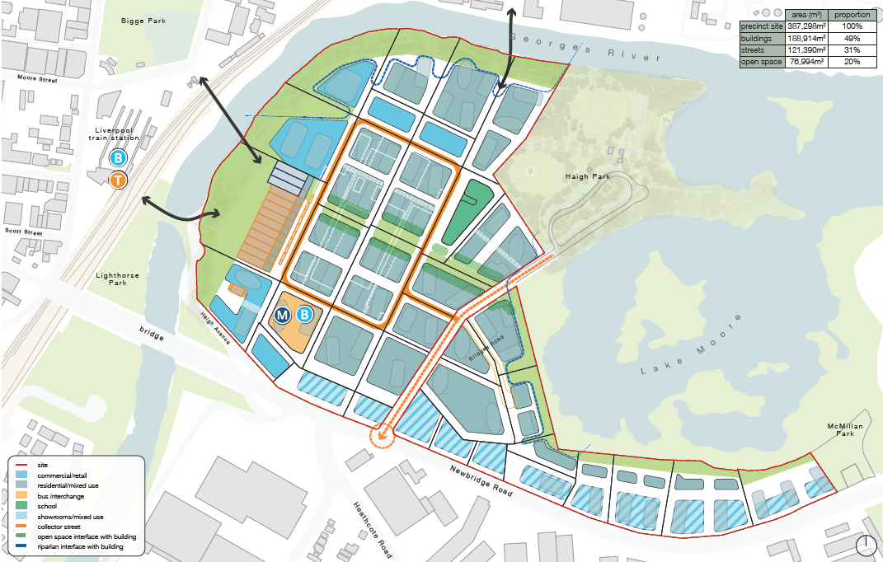
Figure 8: Moore Point Masterplan (Source: SJB)
Of particular importance technical criteria, which outlines how the masterplan has considered the objectives and guidance of current planning policy including State Environmental Planning Policy No. 65 – Design Quality of Residential Apartment Development (SEPP 65) and the Apartment Design Guide (ADG).
The proposed massing represents what could potentially be realised on the site based on environmental and physical constraints. It is anticipated additional technical analysis and sub-precinct design will be undertaken following Gateway Determination to further rationalise the built form and address any additional matters raised through the assessment process.
Following this, a site-specific DCP will be prepared that articulates the relevant built form and planning controls for the site for the character areas within the masterplan.
SEPP 65 Considerations
Building Setbacks
Streets and blocks within the masterplan have been designed to ensure building separation requirements of the ADG can be achieved. All streets and setbacks have been designed to allow a minimum of 20m between podiums, and all block depths have been designed to allow for 18 to 24m separation above podiums. It is anticipated through detailed design, that all buildings will be designed to meet the design guidance and objectives of the ADG.
Solar Access
The nature of the existing grid pattern and the resulting built-form balances the site constrains and addresses amenity through the strategic placement and orientation of uses to maximise solar access in order to meet the requirements of the ADG.
A key factor for consideration with regards to solar access for a precinct this size is the timeframe and staging, which will be driven by market demands meaning the ultimate mix of uses between residential and non-residential may evolve over time. To respond to this, the masterplan ensures there is flexibility within the envelopes to ensure solar access is managed at a block-by-block level at the next stage of planning assessment.
The masterplan proposes the following design measures to ensure solar access requirements can be achieved on each block:
- Orientate towers on a north south axis to maximise solar to a maximum of 8 degrees off north; and
- Maximise apartments on the northern edges of the blocks – locating cores and on-residential uses to the south.
The masterplan provides a balance between a place-based approach (heritage grid, relationship to river and lake) and the requirement for compliance including building separation, overshadowing and solar access. The envisaged masterplan reflects existing site characteristics and optimises place-based opportunities, enabling a level of density that does not compromise on the amenity of surrounding residents or future residents within the site.
Staging
The delivery of the masterplan will be staged up to 2051.The staging only considers the proponents landholdings and does not take into consideration other landholdings in the study area. The approach to staging considers the availability of land over time, and the associated delivery of public open space and community infrastructure.
The staging plan is proposed as follows:
- Stage 1 – North west of the site closest to Liverpool CBD;
- Stage 2 – Predominantly around Haigh Park, Lake Moore and two blocks bound by the internal loop road; and
- Stage 3 – Southern portion of the masterplan closest to Newbridge Road.
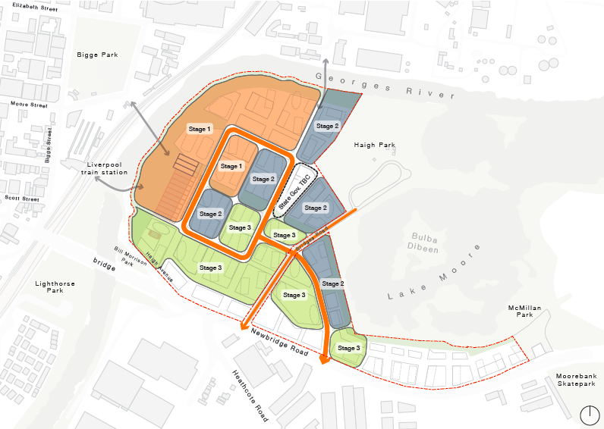
Figure 9: Staging Plan (Source: SJB)
It is proposed to incorporate a detailed staging plan into the site-specific Section 7.11 Contributions Plan following Gateway Determination to lock in the delivery of certain infrastructure items with construction of development.
A Place Design Framework has been prepared by Roberts in support of the Planning Proposal. The Place Design Framework sets out the key principles that will guide activation and decision making at the site transforms and should be read in conjunction with the Urban Design Report prepared by SJB.
Traffic and Transport
A Strategic Transport Impact Assessment has been prepared by Aurecon in support of the Planning Proposal.
The report provides an overview of existing and planned transport infrastructure capable of supporting the Planning Proposal, as well as outlining a two-stage transport investigation assessment during the rezoning process.
The objective of these studies is to ensure the successful integration of Moore Point into the current and future planned transport network of the Collaboration Area. These are detailed below.
Transport Infrastructure Working Group
A Transport Infrastructure Working Group (TIWG) has been established to facilitate an integrated and connected transport vision for Moore Point.
The TIWG will involve TfNSW and Council to ensure the Planning Proposal aligns with the overarching Place Strategy for Liverpool Collaboration Area and the successful integration of Moore Point into the current and future planned transport network.
Stage 1 – Due Diligence and Strategic Assessment
This stage will establish a strategic analysis of the transport infrastructure required to support the Planning Proposal and eventual masterplan. The assessment will be informed by work done by TfNSW to develop a place-based transport strategy for the Collaboration Area and surrounds. The findings will inform development scenarios for further assessment.
The appropriate land use and staging scenarios will be agreed with Council, while also ensuring committed and planned infrastructure are agreed with TfNSW to feed into the assumptions of the baseline scenario.
Once the assumptions and staging scenarios have been agreed, strategic transport modelling will be undertaken using TfNSW Strategic Transport Model (STM) and Public Transport Project Model (PTPM). This will derive the additional distribution of transport demand across various parts of the transport network as a result of land use changes envisaged across the Collaboration Area.
These outputs will be fed into a Strategic Traffic Forecasting Model (FTFM) to inform the strategic transport evaluation component and provide an understanding of the scale of impacts of the Planning Proposal on the transport network.
A summary of this process is provided below.
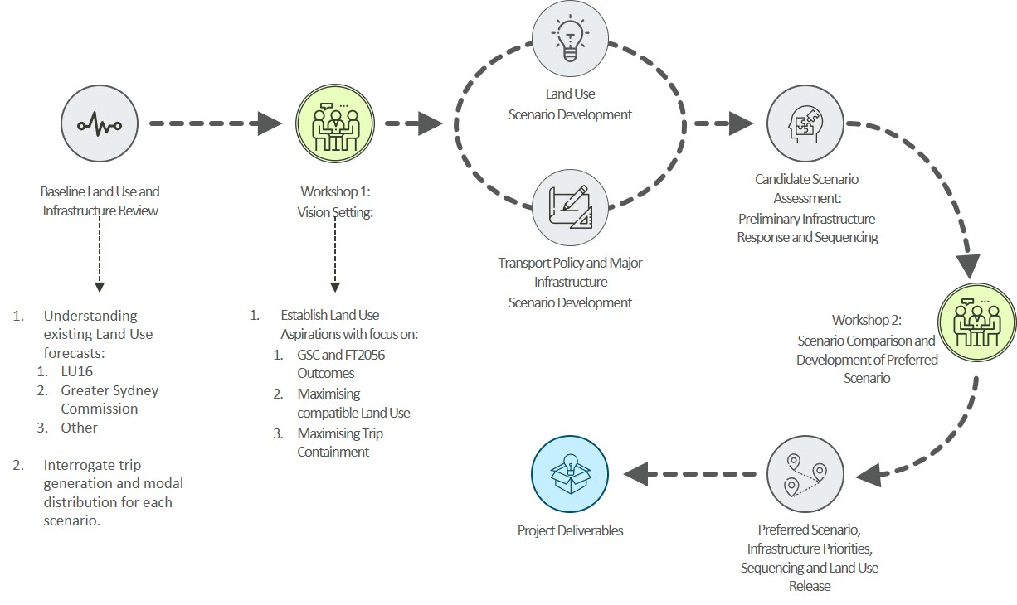
Figure 10: Proposed Stage 1 Approach (Source: Aurecon)
The final deliverable for Stage 1 will be the submission of a Preferred Land Use and Transport Infrastructure Scenario, which will include:
- A Land Use and Transport Strategy for the Collaboration Area;
- A high level cost estimate of key infrastructure requirements and transport access strategy for interim and ultimate development scenarios; and
- An agreed funding mechanism.
Stage 2 – Detailed Transport and Traffic Assessment
Stage 2 will involve the development of a more detailed assessment to assist in accurately identifying and informing the scope and costs for any infrastructure including local transport infrastructure.
A detailed transport and traffic assessment largely in the context of a Transport Management Accessibility Plan (TMAP) will be required to identify the infrastructure and service requirements and determine the development contributions.
It is anticipated that Gateway Determination will be issued with conditions that will align with the outcomes of the Stage 1 Strategic Assessment, to be agreed by the TIWG.
Aviation
An Aeronautical Assessment Report has been prepared by Strategic Airspace in support of the Planning Proposal.
The report examines the current and future regulated airspace height constraints overhead the site that are related to airspace protection requirements that would trigger requirements for an airspace height approval (Obstacle Limitation Surface/OLS) and constrain the maximum permissible envelope heights (Procedures for Air Navigation Services – Aircraft Operations/PANS-OPS). Key findings of the report are summarised below.
Obstacle Limitation Surface
Under OLS, buildings are constrained by height limits which slope up from 76m Australian Height Datum (AHD) at the north-eastern corner to around 108m AHD at the western edge of the site.
Any of the buildings in the site, as well as cranes used from construction, where their maximum heights would penetrate the relevant OLS height constraint overhead would need to be included in ‘airspace height’ applications under the Airports Regulations, for consideration and explicit approval prior to construction. This would not be required until submission of Development Applications at the earliest.
Proposed buildings within the maximum heights that would be lower than the relevant OLS height constraints do not need such ‘airspace height’ approvals.
Figure 11 below depicts which building envelopes, based on the masterplan, would infringe the OLS Conical Surface.

Figure 11: Envelopes which would infringe OLS Conical Surface (Source: Strategic Airspace)
Buildings that gain height approvals may be required to install and operate obstacle lights on either side and/or tops of the buildings, subject to recommendations made by the Civil Aviation Safety Authority (CASA) during their assessment of the height application.
PANS-OPS
Under PANS-OPS, buildings are ultimately constrained by the PANS-OPS circling surfaces, which include Circling Category B (eastern portion of site) with a surface height of 108.12m and Circling Category A (western portion of site) with a surface height of 136.
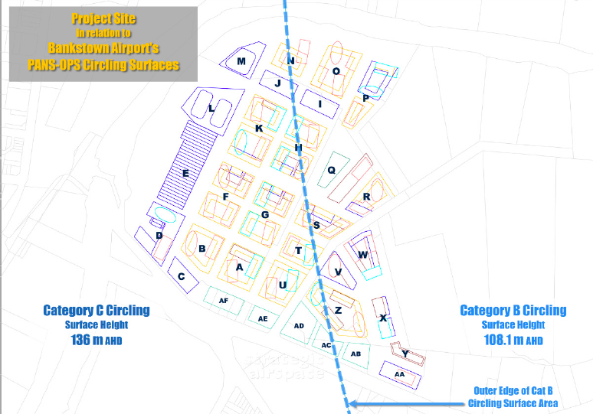
Figure 12: PANS-OPS Category B and C Constraining Surfaces (Source: Strategic Airspace)
None of the proposed buildings in the masterplan would penetrate the limiting PANS—OPS surfaces shown in Bankstown Airport’s prescribed airspace in accordance with Figure 12 above. Therefore, all buildings are considered approvable under the Airports Regulations.
Conclusion
Strategic Airspace conclude that there is no technical impediment to the approval of the proposed development envisaged in the Planning Proposal. It is considered that any future applications for buildings in the masterplan, under the Airports Regulations, supported by a full aeronautical assessment and safety case could be approved by the Department of Infrastructure, Transport, Regional Development and Communications.
Flooding
A Flood Report has been prepared by J. Wyndham Prince in support of the Planning Proposal.
The study details the procedures used and presents the results of the flood impact assessment in support of the site’s redevelopment. It also has developed a flood evacuation strategy to inform the planning process. Key findings of the report are summarised below.
Flood Management
The current floodplain storage during the 1% AEP event has considered the proposed development landform and regional floodplain reclamation strategy. The proposed implementation of the two flood storages and on the banks on the Georges River adjacent to the western motorway will result in an increase in the available floodplain storage by 31,930m3.
The detailed flood assessment completed for the strategy has demonstrated that, with the site, peak flood levels in surrounding properties and within the Georges River will not increase as compared to existing conditions in the catchment in the 1% AEP events. Importantly, provision of the proposed flood levels to the south of Newbridge Road will also reduce the extent of flooding within the Moorebank area, which is therefore considered to be an improvement upon existing conditions.
Water Quantity Management
Peak flow results determined as part of the hydrologic modelling demonstrates the site provides only 0.1% of the total peak flow in the Georges River and therefore, any changes to the characteristics of the site as a result of the Planning Proposal development outcomes will unlikely impact the flow regime of the Georges River.
Therefore, on-site detention is not considered necessary for the Planning Proposal’s development outcomes. Further assessments will be undertaken to confirm that detention is not required as part of the Development Application process.
Flood Evacuation
Flood evacuation routes are identified to ensure a ‘continuous rising grade’ can be maintained to a level above the PMF for all evacuees, with connections to Newbridge Road to the south of the site. In addition, the use of the proposed pedestrian bridges connecting the site to Liverpool CBD will be provide additional early flood evacuation options during a PMF event.
The proposed Flood Management Strategy for the site provides a basis for detailed design and development of Moore Point to ensure that environmental, urban amenity, engineering and economic objectives from stormwater management are achieved.
Riparian
A Riparian Strategy has been prepared by Northrop in support of the Planning Proposal.
The study provides a qualitative assessment of the proposed development in relation to the protection of the riparian corridor zones. Key findings of the report are summarised below.
Findings
For most of the site, the riparian corridor will contain three structured zones, i.e. Riverbank, Inner Vegetation Riparian Zone (VRZ) and Outer VRZ, which is consistent with the NRAR Riparian Guideline. However, the creation of the Georges River foreshore park as envisioned does not conform to the Guideline. Therefore, a merit-based approach to assess this strategy for the entire site is proposed, which relies on offsetting for an overall improved environmental outcome:
Development encroachment into outer VRZ reduced by 6,765m2;
Development encroachment into Inner VRZ reduced by 1,393m2, with total proposed encroachment of only 24m2;
Typically, where there is no native vegetation present in the riparian corridor currently, it will be provided as revegetation representing the ecologically significant communities present around the site. Areas adjoining the Outer CRZ and interfacing with the development will also be revegetated and landscaped in the same manner. This includes offsetting;
The Riverfront zone on the western bank of the site will be variously landscaped. Some of this will be native vegetation and a total of 20% of this area will be dedicated to natives, which counts as offsetting;
As a result, the total amount of revegetated Outer VRZ created compared to the lost is 31,847m2 vs 776m2; and
The total amount of revegetated Inner CRZ and Riverbank created compared to that lost is 16,491m2 vs 5,538m2.
Conclusion
Northrop conclude that the outcomes presented above provide a significant environmental improvement for the site and Lake Moore. The approach has a sound rationale, which justifies a merit-based assessment on this basis. It is proposed that the Placemaking Working Group will further shape and determine the riparian outcomes to achieve the vision for the precinct.
Air Quality
An Air Quality Suitability Study has been prepared by Todoroski Air Sciences in support of the Planning Proposal.
The study provides a qualitative assessment of any likely constraints on air quality relating to the development of the site. Key findings of the report are summarised below.
Findings
The key potential source of air quality impact on the site is the existing water treatment facility on the opposite side of the Georges River along the northern boundary. However, the closest potential sources of odour are located 400m from the nearest proposed new receptors and are generally downwind of the proposal
There are existing receptors that are closer to and also generally downwind of the water treatment facility, therefore significantly lower odour levels than at any existing receptor can be expected at the site.
There is only low potential for impacts from other existing facilities, as these industries are generally good distance away and are not on the prevailing wind axes to the site.
The site would replace existing industry with commercial and residential activities, and therefore it is reasonable to expect some reduction in existing pollutant levels. The residential dwellings also maintain an acceptable setback from existing major roads in terms of siting and height.
Conclusion
Todoroski Air Sciences conclude there is no reasonable indication of any likely air quality impacts that may prevent development at this location. It is anticipated a detailed study would be required as part of the Development Application process.
Contamination
A Contamination, Acid Sulfate Soils and Remedial Strategy has been prepared by EI Australia in support of the Planning Proposal.
The study provides an appreciation of how existing site contamination might affect potential land use changes that may be facilitated by the Planning Proposal. The report identifies areas within the site that are contaminated, or potentially subject to contamination to an extent that could impact on future land uses.
For land identified as contaminated or potentially contaminated, remedial options and data gap enclosures were considered where necessary, to enable a feasible remediation strategy to be developed and make impacted areas suitable for their intended purpose. Key findings of the report are summarised below.
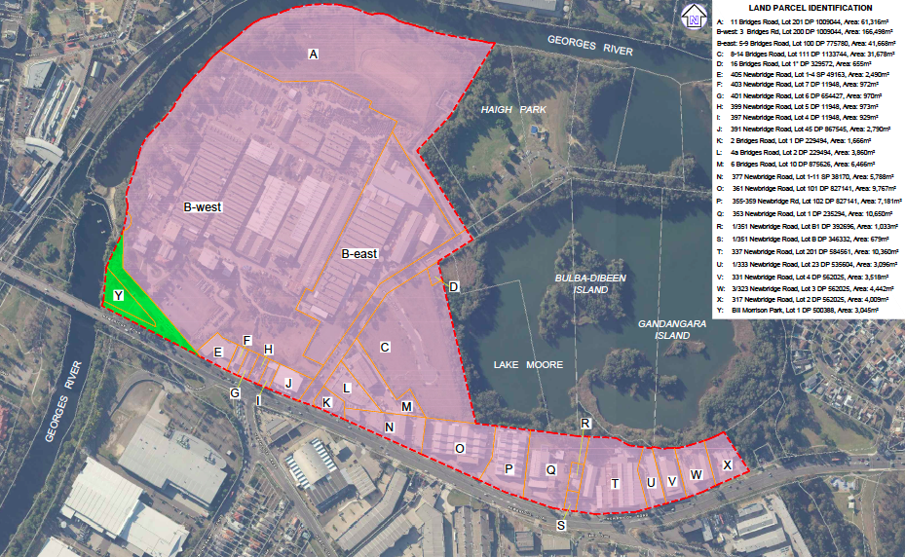
Figure 13: Land Parcel Identification for Contamination (Source: EI Australia)
Findings
Potential Contamination Sources
Based on the reviewed site history and findings documented in the available environmental reports for selected sites, potential contamination sources for the site are summarised as follows:
- Imported fill soils of largely unknown origins used as backfill for relevelling various parts of the site;
- Previous farming, market gardening and cultivation activities, which typically involved the application of chemicals for weed and pest control, fertilisers, petroleum hydrocarbon products used to power and maintain motorised farming equipment;
- The use of handling of paints and other chemicals, including volatile organic compounds (VCOs), during historical and current industrial activities involving manufacturing, chemical reacting, dispensing, treatment and production of liquid waste;
- TCFM, leaked from an underground, concrete liquid waste tank located within the south western portion of Area B-east, which was reported to have migrated westwards to the adjacent property Area B-west at 3 Bridges Road;
- Multiple underground and above ground storage of petroleum fuels (i.e. UPSS and ASTs) particularly within areas B-west, B-east, M and O, some of which are still in use and/or remain in partially decommissioned condition; a
- Deeper, natural soils and groundwater containing residual impacts from leaked hydrocarbons and other chemicals, representing potential secondary sources of contamination;
- Hazardous building materials, including ACM and lead-based paints; and
- Asbestos impacted soils.
Data Gap Closure Requirements
The report identifies the need to establish the environmental conditions for land parcels that have not yet been investigated or have been investigated to a limited extent. These include:
- Area A, B, C, D, M and O.
The following areas within the site require both a Stage 1 Preliminary Site Investigation (PSI) and Stage 2 Detailed Site Investigation (DSI):
- Group 1 (Areas A – E);
- Group 2 (Areas K, L and N);
- Group 3 (Areas P to X); and
- Group 4 (Area Y).
Contamination Summary
A summary of potential contamination sources for each area is provided below:
- Areas A, and D – widespread filling for site releveling purposes;
- Area C was also reported to have received uncontrolled waste from unknown sources, with previous identification of ACM fragments in fill and stockpiles at multiple on-site locations;
- Area B:
  - Area B-west and Area B-east were subject to chemical spills and leaks from the handling and storage of hazardous substances;
  - Area B-west was also subject to burial of industrial waste, including asbestos waste and disused chemical drums;
  - Area B-west, south of Factory, 4 diesel-type phase separated hydrocarbons (PSH), were previously reported on groundwater at former monitoring well WS01 and remedial product recovery works were reported by RES (1999), however it is assumed that further remedial action may be needed in regard to PSH;
  - Area B-west, southeast of Factory 5, at former monitoring ells WS13 and WS14, diesel-type PSH and dissolved petroleum hydrocarbons were previously reported for groundwater located in Area B-west, this was thought to be a result of onsite migration from an up-gradient UST on Area B-east, as reported by AGC-WC (1999);
- Area K – Petroleum hydrocarbon and VOC impacts associated with service station operations at the Caltex Service Station;
- Area F – Plastics extrusion factory, which stores and handles a range of chemicals, including resins, plasticisers, phenols and solvents;
- Area G, J, L, R and S – Mechanical workshops, tyre repair, car wash, and smash repair businesses handling a range of chemicals including metals, automotive fluids, PFAS, oil, grease, paints, resins, plasticisers, phenols and degreasing solvents; and
- Area O – Furniture manufacturing facility, with a disused UST and other potentially contaminating operations including flammable liquids storage, painting and staining of furniture and the onsite burial of ACM in site fill.
Conclusion
EI Australia conclude that the site can be made suitable for the proposed use and that a combination of the following remedial options may be implemented to remediate the site for its intended purpose:
- Excavation and On-site Encapsulation – Involving excavation of impacted soils from bulk excavations that are intended for the construction of basement car parking facilities followed by onsite reuse to the extent possible.
- On-site containment of contaminated soils by way of capping and/or encapsulation within low permeability cells or other appropriately designed barrier system, where subsurface or above-ground storage areas are available. Contaminated materials that are retained on-site will need to be managed under a site-specific LTEMP, which will include periodic groundwater monitoring to confirm that off-site containment migration is not occurring. Should off-site mitigation be detected, then contingent groundwater measures will need to be implemented;
- Excavation and Off-site Disposal – Involving excavation of impacted soils from bulk excavation followed by off-site disposal of surplus impacted soils to licensed waste landfill;
- In-site Soil Vapour Extraction – Coarse grained soils impacted with VOCs (including chlorinated VOCs, light fraction petroleum hydrocarbons and BTEX), may be treated in-situ by extracting soil vapour under vacuum, via horizontal vent pipes installed in trenches throughout the impacted area. The contamination is drawn out of the soil as vapour and liquid, which are collected for appropriate on-site treatment and/or off-site recycling; and
- Ex-situ Bioremediation with Soil Vapour Extraction – Coarse grained soils impacted with VOCs (including chlorinated VOCs, light fraction petroleum hydrocarbons and BTEX), may be treated ex-situ by extracting soil vapour under vacuum, via horizontal vent pipes installed in bio-piles created from the excavation of impacted soils. The contamination is drawn out of the soil bio-piles as vapour and liquid, which are collected for appropriate on-site treatment and/or off-site recycling.
Overall, once the data gap closure investigations are available, the remedial strategy may be refined. A detailed, site-specific remedial action plan (RAP) is required for each site, before the commencement of site remediation.
The site-specific RAP must include an Unexpected Finds Protocol to provide guidance on addressing unexpected contamination that may be identified during the course of site redevelopment.
Heritage
A Historical Heritage Assessment and Aboriginal Heritage Assessment has been prepared by Eco Logical Australia in support of the Planning Proposal.
Historical Heritage Assessment
The Historical Heritage Assessment identifies if historical heritage items were locality to be located within the study area, and if so, whether future development of the area had potential to impact upon the heritage significance of those items.
Part of the site is a locally listed heritage item on LLEP 2008 known as the Pirelli Power Cables and Systems Building (Formerly MM Cables Factory and now known as Prysmian).
Heritage Grading
Grading of items on the site as possessing heritage significance for the Pirelli Power Cables Administration Building and Factory are provided below:
High Significance
- Original Administration Building;
- Original Factory Building No. 1; and
- Original Factory Building No. 2.
Moderate Significance
- Guard house/entry building;
- Rear additions to Factory No. 2; and
- Original landscape layout in front of the Administration Building (including sides and the front gate).
Little Significance
- Rear additions to the Administration Building;
- North bays to Factory No. 1 and No. 2;
- Factory No. 3, No. 4 and No. 5; and
- All other remaining structures.
Intrusive
- West and South additions to Factory No. 1.
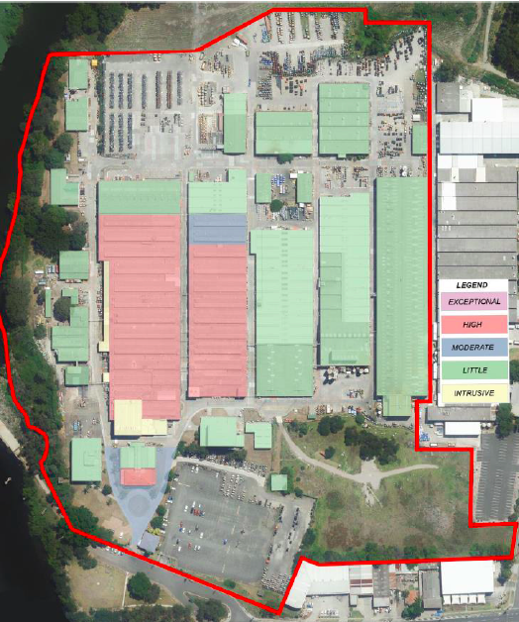
Figure 14: Heritage Significance Grading (Source: Eco Logical Australia)
Assessment
The report refers to the previous heritage assessment undertaken in 2018 by GBA, which identified the heritage significance structures on the site and recognised retention and re-use of the original factory buildings (No. 1 and No. 2) as a priority and preferable to the retention of the Administration building. GBA concludes the original function of the factory buildings are a good representation of the sites function and operational history.
Eco Logical assessed the proposed masterplan and agree with the recommendations provided by GBA. The Administration Building, which is in poor condition, was recommended for demolition by GBA however, it is proposed to retain this in the masterplan and future development.
Conclusion and Recommendations
Eco Logical Australia make the following recommendations with respect to the existing heritage items on site:
- Structures graded as being of little and intrusive heritage significance to be demolished;
- Areas identified as being of moderate heritage significance may be able to have their demolition justified in the context of the overall future development and the necessity for certain elements of the site to be developed within the areas these items occupy;
- The Administration Building will be retained and adaptively re-used;
- The original factory buildings will be retained and re-used to enable reasonable use and interpretation within the context of future development;
- Future development must consider DCP controls for the site;
- In the highly unlikely event that unexpected historical archaeological material is encountered during works, it would be necessary to stop all works in the immediate vicinity of the identified material. The NSW Heritage Council would be notified, and a qualified archaeologist would be engaged to assess the significance of the material and recommend whether further investigation is required.
Aboriginal Heritage Assessment
The Aboriginal Heritage Assessment aims to identify if any Aboriginal objects are likely to be located within the study area of the proposed works and, if so, whether the proposed works will have potential harm to those objects.
Assessment
The study identified one registered Aboriginal heritage site within 1km of the study area, located on the opposite side of the Georges River. No registered AHIMS sites are located within the study area. The report has also reviewed past Aboriginal archaeological studies within and nearby the study area, which have demonstrated the Georges Rifer as an area of high archaeological potential and a focal point of Aboriginal activity in Western Sydney in the past.
A pedestrian survey was conducted of the proposed site. The survey identified almost all areas as having been significantly disturbed by past land use. One portion of the study area, in the north western riparian corridor of the Georges River, has moderate archaeological potential due to the proximity of the Georges River and lack of development in that portion of the site.
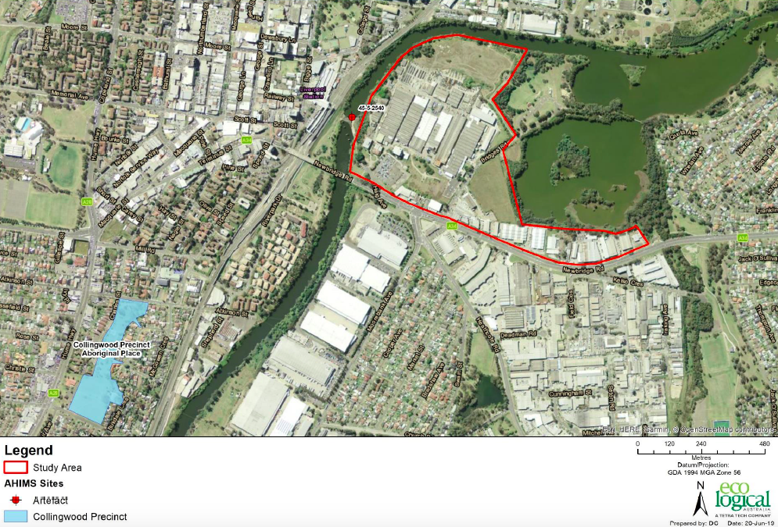
Figure 15: AHIMS Sites within Study Area (Source: Eco Logical Australia)
Conclusion and Recommendations
Eco Logical Australia advise that development is not proposed in the area noted as having moderate archaeological potential, which will be used for a planned riparian corridor. The remainder of the study area possesses low archaeological potential and no further assessment is therefore required.
Nonetheless Eco Logical Australia provide the following recommendations in accordance with the National Parks and Wildlife (NP&W) Act:
Any potential modification to the proposed development area for the site should avoid the north western riparian corridor area identified as possessing moderate archaeological potential. If any development were proposed and could not be avoided, subsurface test excavation is recommended to determine whether the presence of Aboriginal objects is present. If objects are present and an impact is proposed, an Aboriginal Heritage Impact Permit would be required; and
In the unlikely event that human remains are found, works should immediately cease, and the NSW Police should be contacted. If the remains are suspected to be Aboriginal, the DPIE may also be contacted at this time to assist in determining appropriate management.
Sustainability
A Sustainability Statement has been prepared by Integral Group in support of the Planning Proposal.
The statement presents a strategy for how the project will consider sustainability opportunities as it develops through planning, design and infrastructure provisioning.
The masterplan for the site has identified specific design opportunities for delivering a sustainable urban environment including opportunities for:
- Rainwater catchment in parks and in the promenade of the site;
- Green roof provisions for low-rise buildings;
- Building fabric to support passive design;
- On-site renewable energy;
- Use of native plants in urban green space to support biodiversity and habitat connectivity; and
- Land use mix – employment dividend.
A place-making group will be established to drive place-making and urban design, riverfront outcomes and sustainability governance for the site. The Group will have representation from Council, the project team and relevant State agencies. It will interface with the transport group for integrated land use and transport considerations.
The Group will consider sustainability principles aligned with the sustainability priorities of the Place Strategy including:
- Energy efficient, renewable energy and GHG emissions reduction towards net zero emissions;
- Water quality and stormwater improvement;
- Waste, materials and the circular economy;
- Climate change risk mitigation including heat and flood risks;
- Reduced reliance on private cars with support for active mobility;
- Support high amenity public places with canopy cover, green infrastructure and activation; and
- Supporting connected green spaces and urban biodiversity.
- Has the planning proposal adequately addressed any social and economic effects?
Social
A Community Benefits Analysis (CBA) has been prepared by Cred in support of the Planning Proposal.
The CBA assesses the community benefits that could be delivered through the proposal to support a socially sustainable, resilient and connected community and place. Key findings are the report are summarised below.
The CBA assumes the rezoned site will provide 530 dwellings each year beginning mid-2023. This yields approximately 6,900 dwellings by mid-2036.
By 2051, 30,760 residents will live within Moore Point. The forecast population for the site will be a young population, home to young professionals aged 25 to 34, and new home builders aged 35 to 49.
It is therefore important that the envisaged masterplan delivers unique social infrastructure facilities capable of supporting the prospective demographic and contributing the quality and character of the site and its positive impact on the surrounding area.

Community Benefit Opportunities
The following community and place benefits are identified by Cred to support the delivery of a sustainable and resilient place and community including:
- New multipurpose community hub – approx. 2000m²;
- New local facility with indoor and outdoor space – approx. 400m²;
- Repurposing Moorebank Library and Community Centre to a district level multipurpose library facility – approx. 598m² to 2036 and 1,365m² to 2051;
- Deliver 1 new primary school, including Out of School Hours Care built facility;
- Provision of quality early education and childcare centres (under 90 places);
- Deliver a total of at least 7.7. hectares of new quality open space. Should be delivered as 6.2 hectare of local parks of a minimum size of 0.3 hectares to 0.5 hectares. Parks should be within 200m of resident homes;
- Deliver up to 3 new (or embellished) district sports-fields including:
  - 1 new sports-field space within the precinct up to 2051;
  - Embellishments to Haigh Park to deliver additional sports-fields for informal team sports by 2036;
  - Protection and enhancement of Satyam Ghat.
- Up to 4.5/5 playgrounds for young children (0 to 4) by 2051 and up to 4 playgrounds for older children (5 to 11) by 2051 located throughout the precinct next to new open spaces;
- Up to 1 regional/district level outdoor youth recreation precinct. This could be provided through embellishment to existing Kelso Skate Park or through a new youth focused outdoor recreation space;
- 1 indoor recreation centre providing up to 4 indoor courts that support a range of culturally appropriate sports such as futsal, indoor volleyball, badminton and table tennis;
- Provision of a water launch point for passive boating and viewing decks for passive recreation and fishing at Lake Moore;
- Communal pools or a contribution to improving facilities at Whitlam Centre;
- Provision of communal facilities within residential towers; and
- Affordable housing for key workers.
The Planning Proposal is capable of delivering upon many, if not all, of the community infrastructure items recommended by Cred and are detailed within the masterplan. The Placemaking Working Group may provide advice on the location of community infrastructure items. Some of these will be delivered off site through contributions to existing facilities and their enhancement. Infrastructure funding for specific items will be dealt with separately through a site-specific Section 7.11 Contributions Plan to be prepared in collaboration with Council following Gateway Determination.
Economic
An Economic Impact Assessment (EIA) has been prepared by Hill PDA in support of the Planning Proposal.
The report provides an independent economic assessment of site and quantifies the economic impact or benefits of that the masterplan would provide over that already generated on the site under its current industrial zoning.
This section does not cover the loss of industrial land or relocation of urban services, as this has been discussed at other relevant sections.
Economic Benefits (During Construction)
Based on a construction cost of $8.72 billion and construction life span 30 to 40 years, the economic benefits resulting from the Planning Proposal are estimated at:
- $11.2 billion of activity in production induced effects;
- $7.9 billion in consumption induced effects;
- Total economic activity generated by the construction of the proposed masterplan of around $27.8 billion;
- 21,762 job years, equating to 544 and 725 jobs generated directly per annum;
- 87,503 job years, equating to 2,185 and 2,913 jobs generated directly and indirectly per annum; and
- Around $50 million of additional retail expenditure from construction workers on-site during the period of construction. This equates to around $1.3 to $1.7 million per annum over the construction period. The majority of this would be captured by local retailers.
Economic Benefits (Post Construction)
Upon completion, the Planning Proposal’s envisaged masterplan would provide approximately 344,499m2 gross floor area of employment space and 14,789 dwellings. The provision of these land uses on site would potentially increase the economic output of the site, Liverpool and the wider District.
The table prepared by Hill PDA describes the outputs that would result from the development compared to that currently estimated to be generated on-site with current industrial uses (base case).
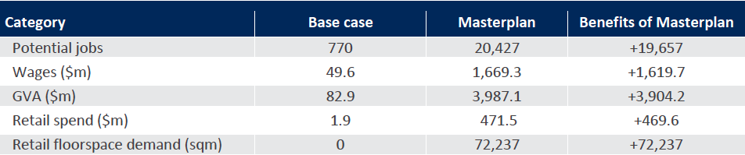
Table 6: Base Case Versus Planning Proposal (Source: Hill PDA)
The table confirms the masterplan would generate an addition 19,657 jobs, $1.62 billion in wages and contribute $3.9 billion per annum to local economy or GDP.
Non-resident workers on-site would also generate an estimated $94 million per annum in retail expenditure that would be captured by local retailers. This is around $92.1 million greater than that already estimated to be generated under the base case.
In addition, the Planning Proposal would generate economic benefits resulting from the resident’s on-site. These economic benefits primarily relate to increased residential expenditure, which could be captured by retailers in the locality including Liverpool CBD. This is estimated at an additional $377.5 million per annum.
The population would also increase the demand for retail space by around 72,237m2, the majority of this would be likely directed towards surrounding retail centres, such as Liverpool, which would increase the vibrancy, viability and attractiveness towards investors.
Hill PDA also note the following additional economic benefits including:
- Providing a catalyst for further investment in the locality;
- Contributing to increasing housing diversity and affordability in the LGA and District;
- Providing jobs closer to home and contributing to the LGAs employment targets;
- Contribute to transit oriented development objectives by concentrating more people near the train station and commercial services, thereby reducing the reliance on private motor vehicle travel and increasing public transport usage; and
- Contributing to Sydney achieving the 30-minute city concept.
Conclusion
Overall, Hill PDA confirm the Planning Proposal is supportable from an economic perspective.

Section D – State and Commonwealth interests

- Is there adequate public infrastructure for the planning proposal?
Infrastructure Servicing
The site is well serviced by existing transport, infrastructure and services.
A Services Infrastructure Report has been prepared by ADW Johnson in support of the Planning Proposal.
The report made applications to Endeavour Energy, Sydney Water, NBN Co and Jemena in relation to the provision of infrastructure to service the Planning Proposal and future development outcomes.
All authorities have advised that they can service the proposed overall development outcome. In some cases, upgrades to the existing network will be required. This is summarised below.
Sydney Water
- Upgrade of potable water supply likely;
- Major upgrade of existing pumping station to be completed to service development. The upgrade works will be completed by Sydney Water and take an estimated 3 years from concept to completion.
Endeavour
- Eight new 11kV feeders from Moorebank Zone Substation;
- Six new circuit breaker terminations at Moorebank Zone Substation; and
- Two new switching stations at Moorebank Zone Substation.
NBN Co
- Fibre connecting the site to the existing Liverpool Fibre Access Node (FAN) to be constructed by NBN,
Jemena
- Installation of below-ground regulator station.
Notwithstanding the above, the Planning Proposal includes the provision of new public infrastructure including new roads, open space, pedestrian pathways, cycleway and bridge crossings. This proposed infrastructure will benefit the surrounding context in the short, medium and long-term.
Site-Specific Section 7.11 Contributions Plan
In addition, a letter has been prepared by Mecone as a statement of intent to prepare a site-specific Section 7.11 Contributions Plan (s.7.11 Plan) in support of the Planning Proposal on behalf of the proponent. This will involve amendment to the current Liverpool City Centre Contributions Plan, which currently includes part of Moore Point in the Section 7.12 levy area.
The letter serves as initial consideration by Liverpool City Council (Council) with the intent to prepare a detailed s.7.11 Plan following the issue of a Gateway Determination by the Department of Planning Industry and Environment (DPIE).
Specific to the Planning Proposal, items captured through the Plan could include:
- Multi-purpose community centres;
- Rehabilitation and embellishment of the Georges River foreshore and Lake Moore;
- Pedestrian bridge/s from Moore Point to Liverpool CBD;
- Dedicated pedestrian and cycle paths;
- Creation of new open space along Georges River foreshore;
- Heritage conservation and adaptive re-use of existing heritage building as new marketplace;
- Embellishment and upgrade of existing open spaces in the surrounding locality;
- Intersection upgrade works at Newbridge Road; and
- Creation of new local streets and collector roads.
Interim Letter of Offer
An Interim Letter of Offer has been provided by the landowners for a public benefits package, which may include a Voluntary Planning Agreement (VPA) for additional infrastructure to support the development, where this can not be levied through a Section 7.11 scheme, such as
- Dedication of foreshore open space along the Georges River; and
- Delivery of combined flood storage and recreation/playing courts near Helles Avenue.
- What are the views of state and Commonwealth public authorities consulted in accordance with the Gateway determination?
There has been no consultation with Commonwealth public authorities or State Government authorities, as the proposal has not yet received a Gateway determination. This consultation will be undertaken during the community exhibition phase.

Part 4 – Mapping
A comparison of existing controls and proposed controls is provided in Table 7.
Table 7: Existing vs. Proposed Controls
Control | Existing | Proposed
Zone | IN2 – Light Industrial | B4 – Mixed Use  B6 – Enterprise Corridor  RE1 – Public Recreation
Height of Buildings | 18m and 15m | 136 RL and 108 RL
Floor Space Ratio | 0.75:1 | 4.2:1 and 3.5:1
Changes are reflected in amendments to the mapping as shown in the figures below.
Note: Areas marked white hatching do not apply to the subject Planning Proposal amendment.

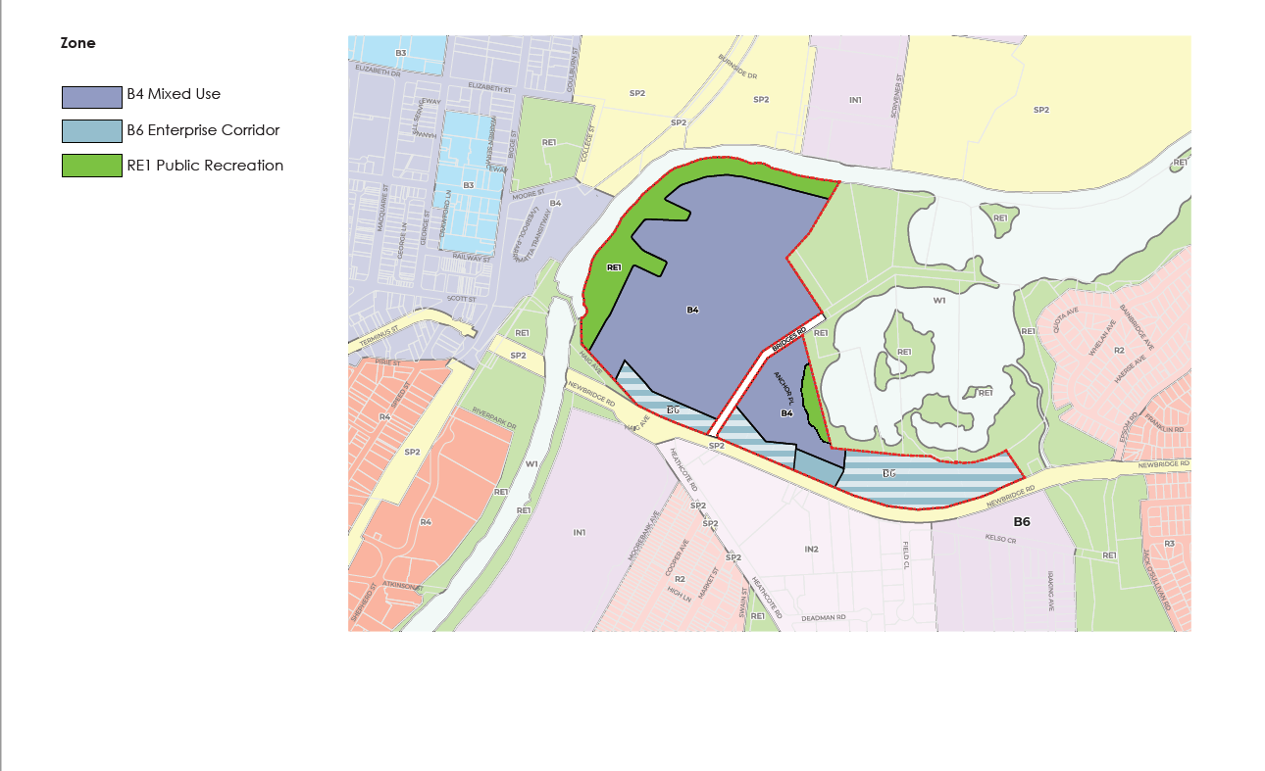
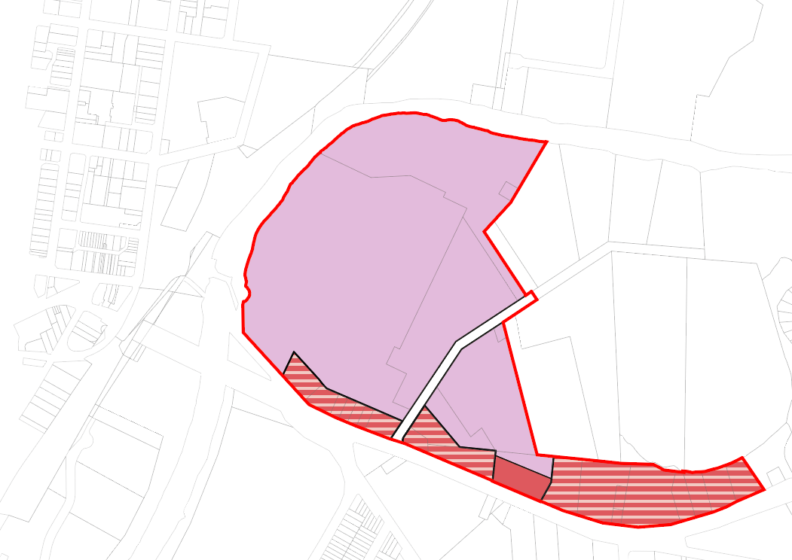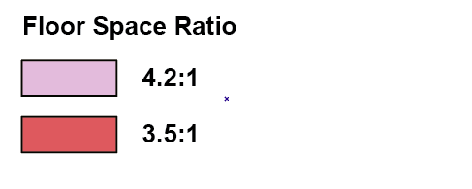
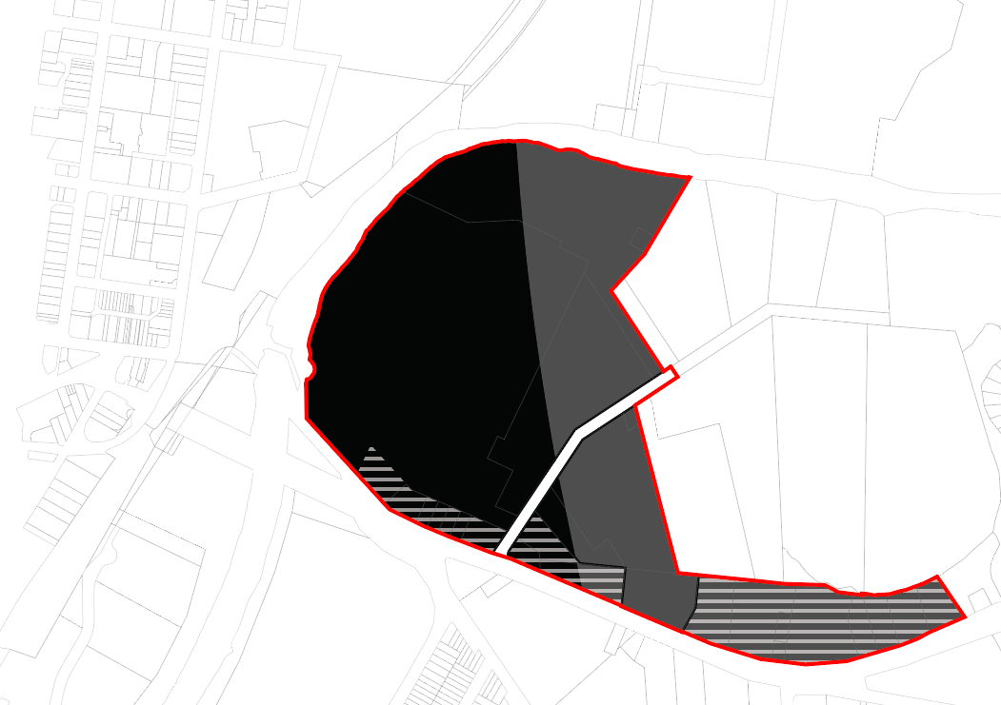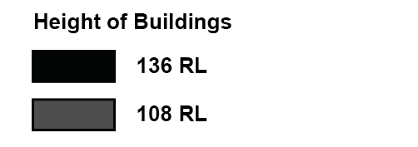
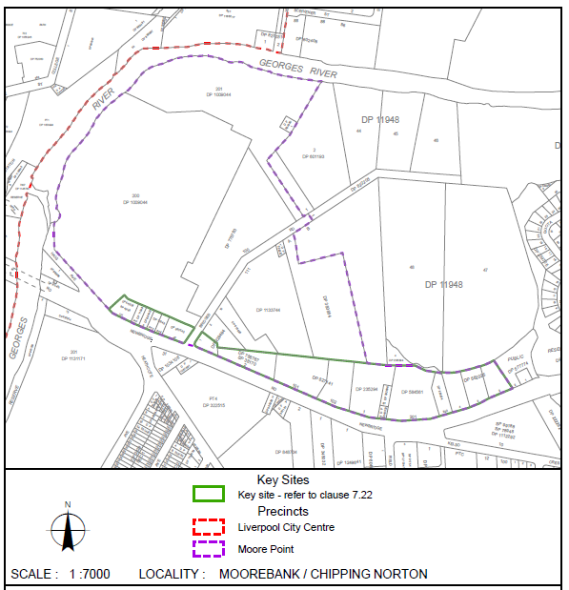
Figure 16: Proposed LEP Maps (Source: LLEP 2008 Modified by Mecone and Liverpool City Council)
Note: A Council resolution has indicated an additional 1.5 hectares of RE1 open space may be required on-site, however this will be determined following the completion of an Open Space needs assessment. The extent of the RE1 area around Lake Moore may also be refined following further studies to define the top of bank.

Part 5 – Community Consultation

Schedule 1, Clause 4 of the EP&A Act requires the relevant planning authority to consult with the community in accordance with the Gateway determination. The planning proposal will be publicly exhibited for a minimum of 28 days, as specified by Gateway determination, with notice requirements for public exhibitions adhered to.
Council will also consult with relevant public authorities/organisations under section 3.34(2)(d) of the Act and/or to comply with the requirements of relevant section 9.1 Directions:
- Relevant infrastructure servicing authorities; and
- Roads and Maritime Services (Transport for NSW).

Part 6 – Project Timeline
An anticipated project timeline is shown in Table 8.
Table 8: Indicative Project Timeline
Timeframe | Action
October 2020 | Presented at the Local Planning Panel meeting
November 2020 | Presented to Liverpool City Council
December 2020 | Gateway Review
April 2021 | Gateway Determination issued
April-July 2021 | Anticipated timeframe for the completion of required technical information.
July-September 2021 | State agency consultation
August-September 2021 | Community consultation
September-October 2021 | Consideration of submissions and proposal post-exhibition
October 2021 | Post-exhibition report to Council
November 2021 | Date of submission to the Department to finalise the LEP.
February 2022 | Anticipated date Relevant Planning Authority (RPA) will make the plan (if delegated).
February 2022 | Anticipated date RPA will forward to the Department for notification.

Conclusion and Recommendations

The planning proposal has been prepared in accordance with:
- Section 3.33 of the Environmental Planning and Assessment Act 1979 (the Act); and
- The NSW Department of Planning and Environment’s (DP&E) A guide to preparing planning proposals.
The site is located comprises multiple allotments east of Liverpool CBD on the opposite side of the Georges River and north of Newbridge Road. It provides a site area of 32 hectares (approx.) and is currently developed with industrial uses.
The Planning Proposal seeks to realise the ultimate vision of Moore Point as an extension of Liverpool CBD, as manifested through the creation of LLEP 2008, ongoing strategic studies up to the LSPS.
This report provides a full justification of the proposal in line with the Department of Planning and Environment’s template for gateway rezonings. The justification demonstrates that the proposal:
- Realises Government objectives for the Georges River North Precinct, expressed both through the Place Strategy and LSPS, to provide a mixture of uses that complement the Liverpool CBD;
- Complements the objective of Liverpool Collaboration Area as a “rejuvenated river city”;
- Assists the collaboration area in achieving its 2036 job and housing targets, which include 18,800 new dwellings and 16,200 new jobs;
- Ensure infrastructure is delivered in line with development;
- Celebrates local character and heritage through the adaptive re-use of existing heritage items;
- Provides future housing and jobs within close proximity of a potential future Metro connection to Bankstown and the FAST Corridor;
- Enhances access to the Georges River foreshore and improve opportunities along the waterfront;
- Provides ample active and passive recreation opportunities for residents and workers in the area;
- Acts as a statement of intent to set a benchmark for new development in Moorebank that prioritises a high quality public realm;
- Provides new public domain infrastructure and uses conducive to the foreshore nature of the site;
- Delivers new pedestrian and cycleway improvements along the foreshore, and additional connections from the site to Liverpool CBD and Train Station;
- Provides a mix of uses within excellent access existing public transport, community infrastructure, health and education services and Liverpool CBD;
- Enables new services and accommodation in close proximity to the Liverpool Health and Education Precinct and Innovation Precinct; and
- Provides high quality mixed use development, which will facilitate opportunities for new employment, housing choice and public amenity.
The Planning Proposal demonstrates the built form and land use propositions sought via amendments to LLEP 2008 are suitable for a Gateway determination, with recommended conditions placed on the Gateway, including the completion and/or revision of the following studies:
- site contamination study;
- acoustic study;
- flood study;
- flood evacuation study; and
- transport impact assessment.
The development of a Section 7.11 Contributions Plan and site-specific DCP should also be conditioned.
Council also requests that the Department play an active role in the planning process given the strategic significance of this proposal to Liverpool and Greater Sydney.

